I. Atmosphere

1. Origin

a. About 3.5 billion years ago, the surface had cooled enough to form a crust, still heavily populated with volcanoes which released steam, carbon dioxide, and ammonia.

b. This led to the "second atmosphere", which was primarily carbon dioxide and water vapor, with some nitrogen but virtually no oxygen

c. This second atmosphere had approximately 100 times as much gas as the current atmosphere. It is generally believed that the greenhouse effect, caused by high levels of carbon dioxide, kept the Earth from freezing.

d. During the next few billion years, water vapor condensed to form rain and oceans, which began to dissolve carbon dioxide

e. Photosynthesizing plants would later evolve and convert more carbon dioxide into oxygen.

f. As oxygen was released, it reacted with ammonia to create nitrogen; in addition, bacteria would also convert ammonia into nitrogen.

g. With the appearance of an ozone layer (ozone is an allotrope of oxygen) lifeforms were better protected from ultraviolet radiation. This oxygen-nitrogen atmosphere is the “third atmosphere.”

2. Present atmospheric gases – 78 % nitrogen; 21 % oxygen; less than 1 % all others

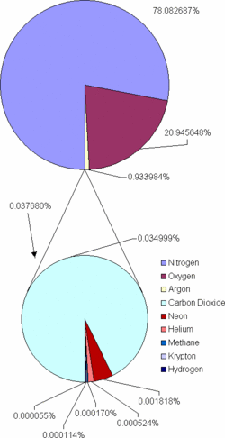

II. Atmospheric Layers

1. Troposphere – lowest portion of the atmosphere; extends up to 10 km (6 mi.) above surface of Earth; virtually all human activity takes place here.

Tropopause – boundary bewteen the troposphere and
the stratosphere.

2. Stratosphere – between 10 and 50 km (6 to 30 miles) above the Earth’s surface

a. Ozone layer – between 19 and 48 km is a layer of O₃ that blocks ultraviolet radiation from reaching the Earth’s surface.

CFCs (chlorofluorocarbons) are chemical compounds that can break apart the ozone layer.

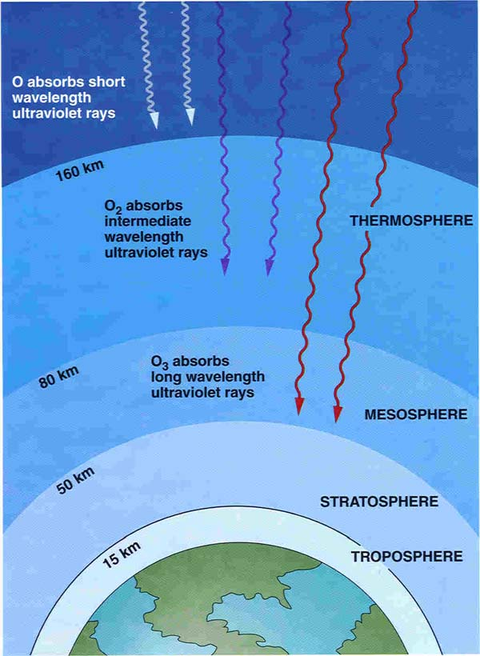

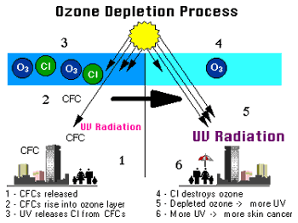

3. Mesosphere – between 50 and 85 km (30 and 43 miles) above surface

4. Thermosphere – between 85 km and 500 km (43 miles and 300 miles) above surface. Meteors and space shuttles operate here.

a. Ionosphere – region of charged particles used for bouncing radio signals back to Earth.

b. Exosphere – extends 500 km (300 miles) and beyond the surface. Satellites exist in this region.

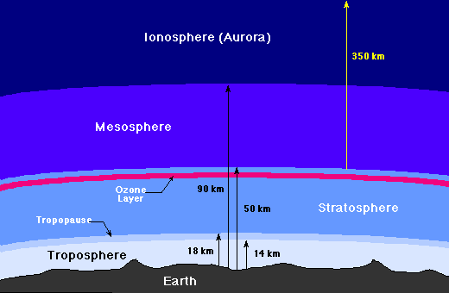

III. Magnetosphere – The magnetosphere is that area of space, around the Earth, that is controlled by the Earth's magnetic field.

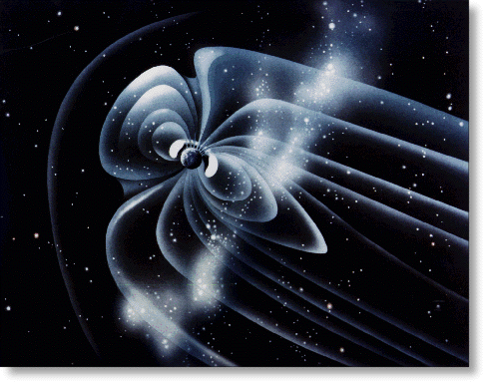

IV. Energy transfer

1. Heat – the measure of the energy of the particles in a particular substance (Earth).

2. Transfer of heat – the movement of energy from “warm” to “cold”.

a. radiation – energy that is transferred in the form of rays or waves.

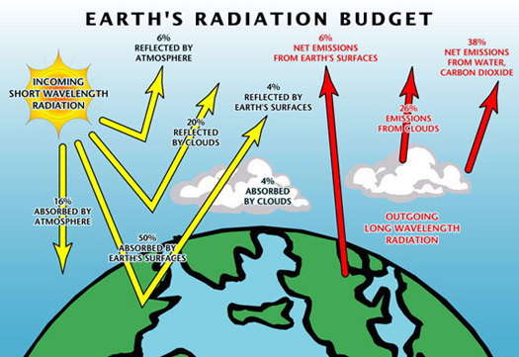

b. conduction – transfer of energy when molecules bump into one another.

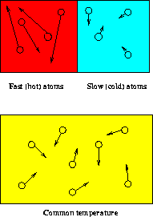

c. convection – transfer of heat by the flow of material.

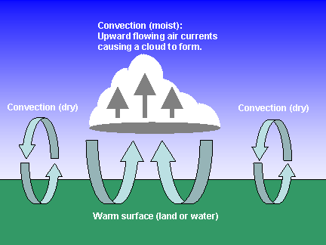

V. Air movement

1. Coriolis effect – the turning of the Earth appears to make air and water turn to the right (north of equator) and to the left (south of the equator).

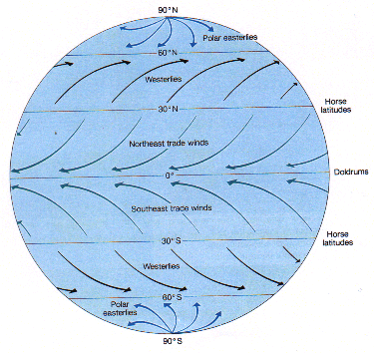

2. Global winds

a. Equatorial doldrums – heating causes air to expand; little air movement; lots of rainy weather.

b. Trade winds – as the warm air from the equator rises and sinks, the Coriolis effect deflects it to the west providing a wind pattern for sailors.

c. Westerlies – 30 degrees above and below the equator air is deflected west to east; move weather systems across continents (like North America)

d. Polar easterlies – dense air sinks and moves away from the poles. The Coriolis effect deflects the air from east to west.

3. Jet stream – a narrow belt of strong wind near the top of the troposphere; separates the cold polar air of the north from the warmer tropical air of the south.

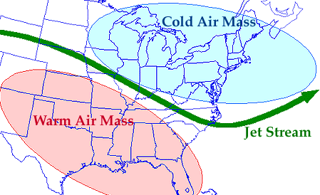

4. Sea breeze – daytime breeze that blows air from sea to land; caused by convection.

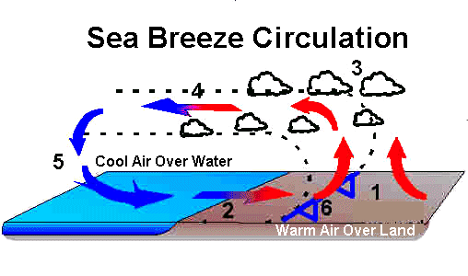
5. Land breeze – also caused by convection, during the night; cooler air over land sinks and blows from land to sea.

