I. Oceans – 71% of Earth’s surface/97% of all water

1. Pacific – largest on Earth; area and volume larger than Atlantic and Indian combined; deepest at avg of 3940 m

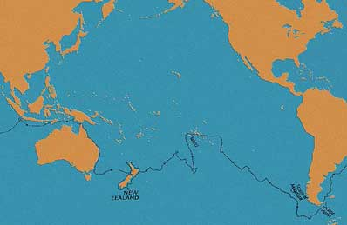

2. Atlantic – second largest; avg depth of 3350 m

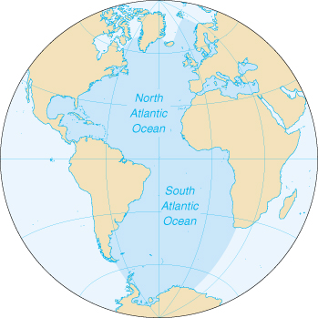

3. Indian – smallest ocean, but greater avg depth

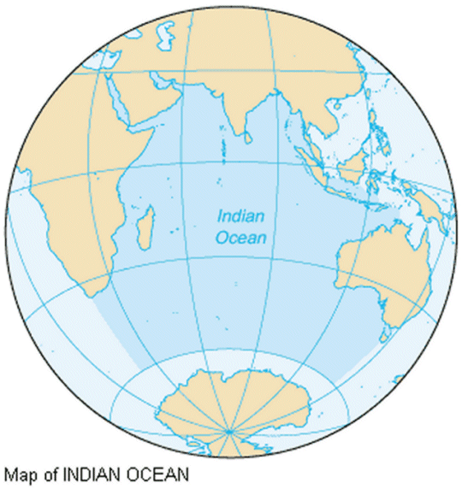

II. Ocean Salts – predominantly sodium chloride

1. Salinity – the amount of dissolved salt (in grams) per kilogram of ocean water

2. Other salts – magnesium chloride, magnesium bromide, potassium sulfate (pg. 211)

III. Temperature Zones

1. Surface Zone – region of water that is mixed by waves and currents (top 300 m)

2. Thermocline – seasons/currents alter its depth (up to 800 m below); water temp. drops rapidly; separates surface zone from deep zone

3. Deep Zone – temperatures only decrease slightly, but very cold overall (above 1500 m only 4 degrees Celsius)

IV. Ocean topography

1. Shoreline – boundary where the land and ocean meet

2. Continental margin – sediments from the land are worn away and deposited here

A. Continental shelf – relatively flat; slight downward slope covered by shallow ocean water

B. Continental slope – boundary between the crust of the continent and the crust of the ocean floor; plunges steeply

C. Continental rise – separates slope from the ocean floor

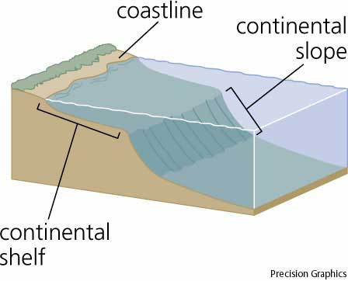

3. Submarine canyon – deep V-shaped valleys cutting through rock in shelf and slope

V. Ocean floor features

1. Abyssal plains – large flat areas on the ocean floor

2. Sea mounts – underwater mountains; volcanic; rise 1 km above ocean floor

3. Guyots – sea mounts with a flat top as a result of erosion

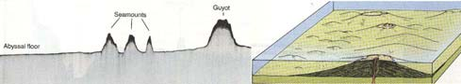

4. Trenches – long, narrow crevices that can be more than 11,000 m deep

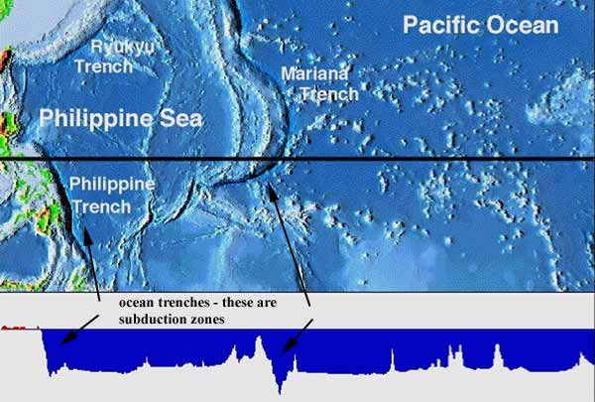

5. Midocean ridges – underwater mountain ranges; formed when molten rock rose through ocean floor and cooled

6. Rift valleys – deep crevices that run between mountain ridges; lots of earthquake/volcano activity

7. Reefs – limestone rock formations that contain the shells of animals (coral reefs); tropical water only

A. Fringing – coral reefs that touch the shoreline of a volcanic island

B. Barrier – separated from shore by lagoon; islands they surround partially sunk; larger than fringing

C. Atoll – surrounds an island that has been worn away and sunk beneath the ocean

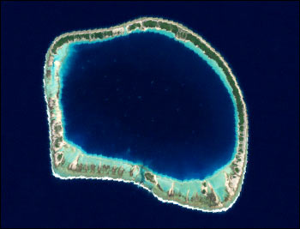

VI. Ocean life zones

1. Intertidal Zone – regions that lie between the low and high tide zones

2. Neritic – region that spans the low tide zone to the edge of the continental shelf

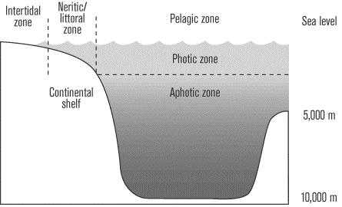

3. Open ocean zone

A. Bathyal subzone – begins at continental slope and extends downward about 2000 m

B. Abyssal subzone – no sunlight, extends to plains on the ocean floor (approx. 6000 m average)

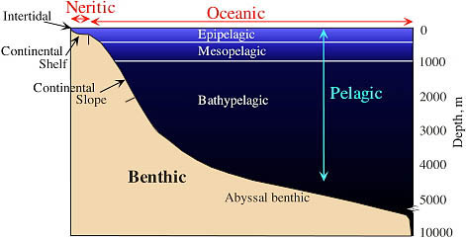

VII. Life Forms – categorized by the depth at which they live

1. Plankton – largest group of plants/animals; float near surface where sunlight penetrates

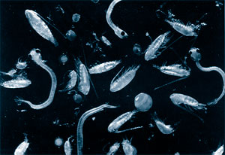

2. Nekton – forms of life that swim in the ocean (fish, whales, dolphins, etc.)

3. Benthos – organisms that live on the ocean floor
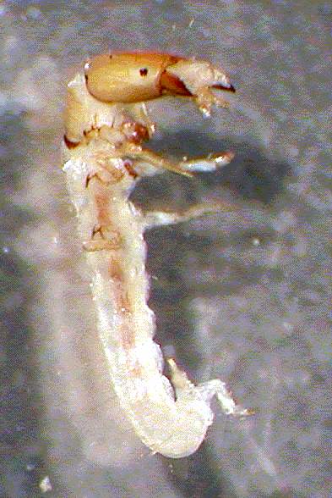

VIII. Ocean Movements

1. Waves – pulses of energy that push water across the ocean

A. Swells – long, wide waves that are not very high

B. Tsunamis – caused by earthquakes; very deep and as they approach shore, pile on each other to form large wave heights

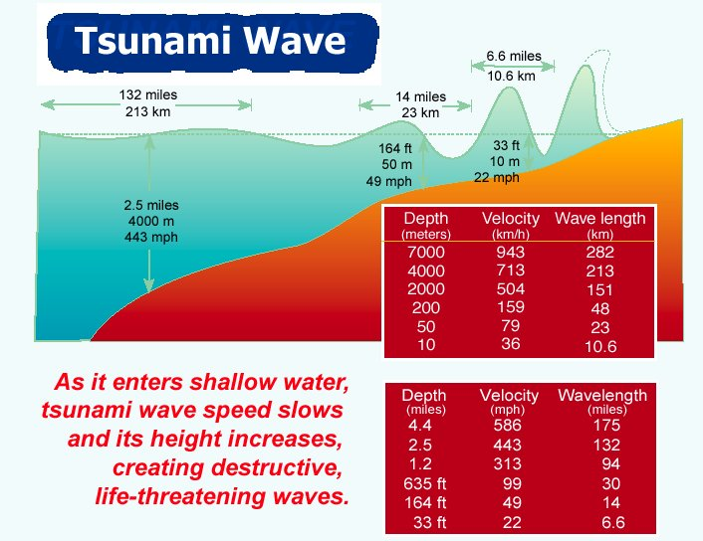

2. Currents

A. Surface currents – caused by wind patterns (largely)

B. Deep Currents – caused by cold water from poles (more dense) moving under warmer (less dense) water

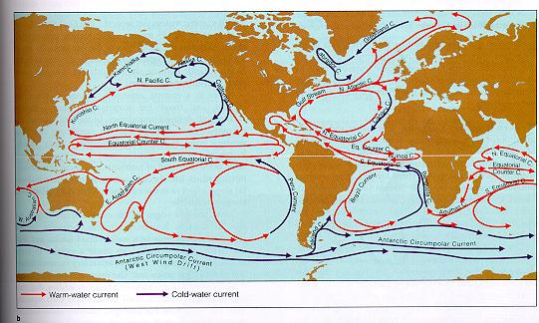

C. Long Shore Currents – responsible for rip tides/cutting through a sandbar

3. Tides – moon’s gravitational pull creates a bulge on the surface of the earth/ocean’s swell and water rises

