I. Earthquake

1. Definition – shaking or trembling of the earth’s crust as a result of a sudden move in the earth’s crust.

2. San Andreas Fault – responsible for some of the worst earthquakes in U.S. history (1906, 1989).

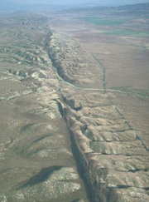

Long fault line through California – nearly 600 miles long and close to 20 miles deep.

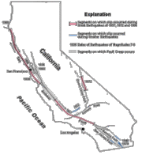

3. Seismic Waves – is a wave that travels through the Earth, often as the result of an earthquake or explosion.

A. Focus – point beneath the earth’s surface where the rocks in a plate break and move

B. Epicenter – the point above the focus at the earth’s surface

Seismic waves most violent here

Seismic waves reach epicenter first

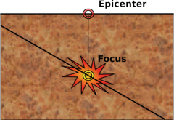

C. Primary or P Waves – seismic waves that travel the fastest; arrive at any given point before any other waves; referred to as push-pull waves; travel through all types of material

D. Secondary or S Waves – they only travel through solids; not always recorded during an earthquake because they are absorbed when they reach the liquid interior of the earth.

E. Surface or L Waves – slowest moving waves; moves along the earth’s surface from the epicenter outwards (like the ocean’s waves); cause most of the damage during an earthquake.

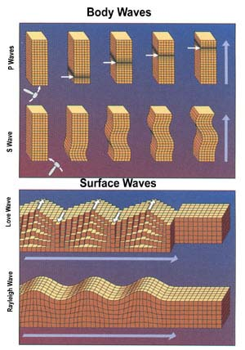

4. Seismic Graph – or seismograph, is an instrument that detects and measures seismic waves.

5. Richter Scale – is a way of determining earthquake strengths based on readings from seismographs. Each successive number on a scale is ten times stronger than the previous number.

II. Volcanoes – are the places on the Earth’s surface (usually mountains) where magma (which becomes lava) and other materials reach the surface.

1. Magma – rock that is deep under the Earth’s surface under extreme temperature and pressure, it is actually a liquid.

2. Lava – the name for magma when it reaches the Earth’s surface.

3. Eruptions – can be “quiet” (lava oozes from surface, little to no dust; others are violent (material is thrown hundreds of feet into the air).

A. Lava types – there are four main types

1) Malfic – dark colored and contains a lot of water; rich in iron and magnesium.

a) Pahoehoe – Hawaiian word meaning "smooth, unbroken lava" is basaltic lava that has a smooth, hummocky, or ropy surface.

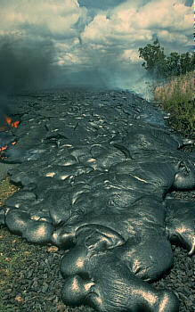

b) Aa – Hawaiian word meaning stoney with rough lava, but is characterized by a rough or bubbly surface composed of broken lava blocks.

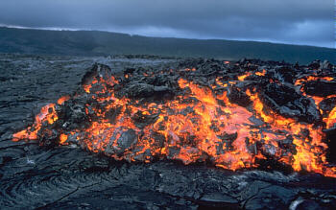

2) Felsic – light in water content and light in color, it contains lots of aluminum and silicon.

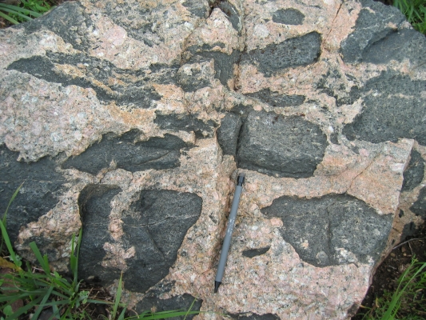

3) Composite – has a chemical composition between that of felsic and malfic.

4) Gaseous – contains large amounts of gases like steam and carbon dioxide.

4. Volcanic Fragments

A. Volcanic dust – particles that very fine (less than 0.25 millimeters), the size of flour particles.

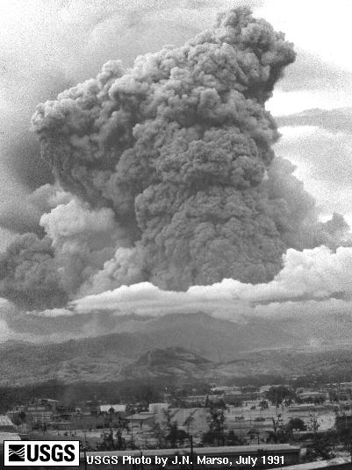

B. Volcanic Ash – rock particles that are more than 0.25 millimeters, but less than 5 millimeters.

C. Volcanic Bombs – range from only a few centimeters to several meters in diameter. The largest ones can have masses of several tons.
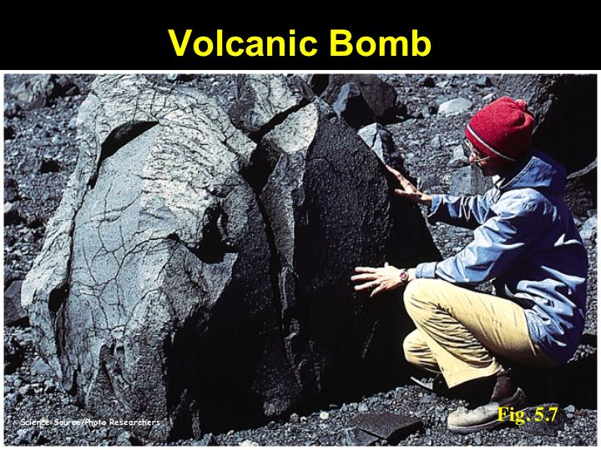

III. Volcanic Cones

1. Shield – volcanoes composed of quiet lava flows; they are runny and the lava flows over a large area.

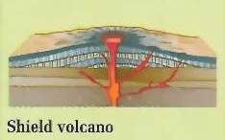

2. Cinder – made largely of cinders and other rock particles that have been blown into the air; formed from explosive eruptions.

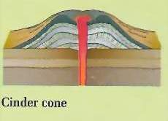

3. Composite – they are built of alternating layers of rock particles and lava; usually formed from an explosive eruption followed by a quiet eruption.

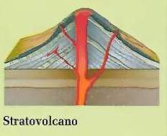

4. Crater – a funnel shaped depression at the top of a volcanic cone.

5. Caldera – if a crater becomes large as a result of its walls collapsing on itself.

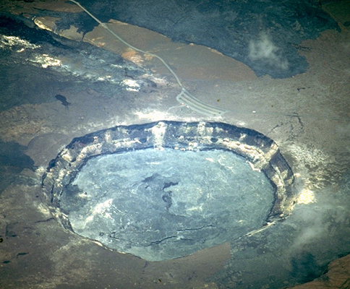

IV. Location of Volcanoes

1. Subduction zones – regions where the Earth’s crust will frequently overlap each other as a result of shifting of plates

2. Mid-ocean ridges – due to the formation of new parts of the Earth’s crust along the ridge.

3. Hot spots – Ring of Fire:

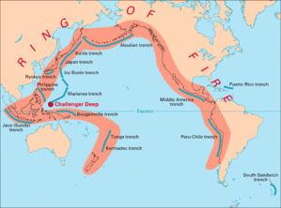

Mediterranean Zone:

V. Volcanism in the Solar System

1. Earth’s moon – no large volcanoes, but has features such as rilles (long narrow depressions in the moon’s surface) and domes

2. Mars – Olympus Mons – all of Mars’s volcanoes are extinct, but this one is the largest mountain (27 km or 16.2 mi) and shield volcano in the solar system

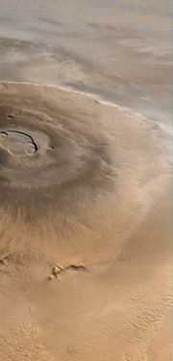

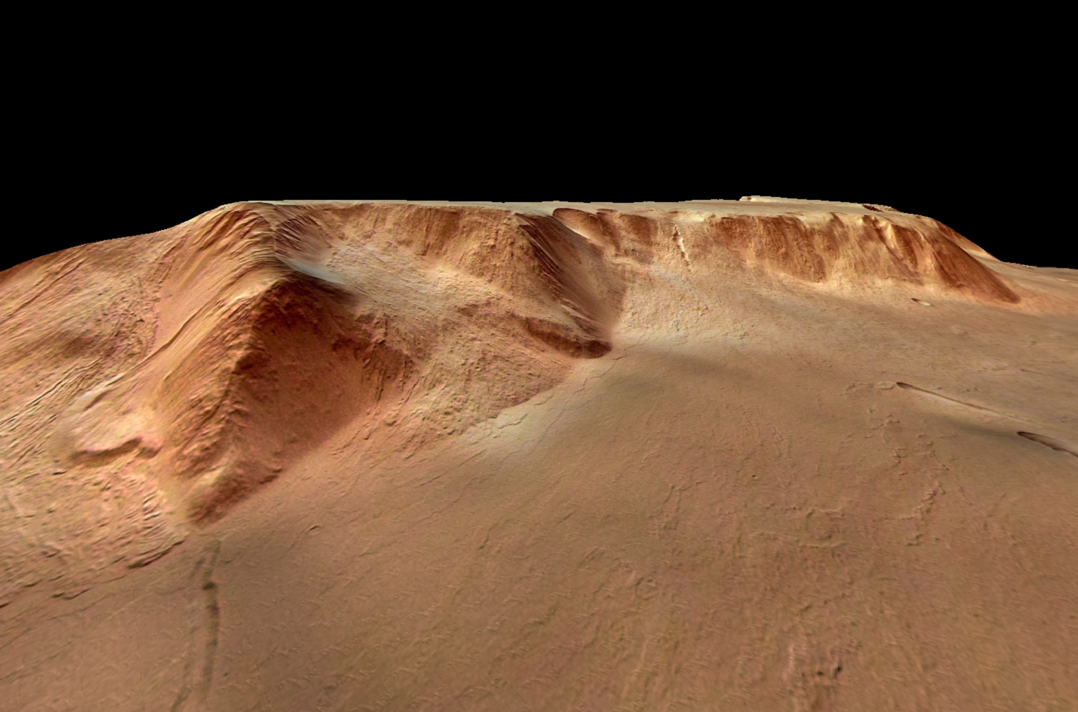

3. Io – a moon of Jupiter – the most volcanic object in the solar system

