Optical telescope – uses magnification of far away objects (through a lens) to show objects.

Radiotelescope – determines the location of stars by the frequency and strength of the radiation it emits.

Spectroscope – measures visible properties of light over a portion of the electromagnetic spectrum

Electromagnetic spectrum – a collection of radiation that travels at the speed of light.

Galaxy – a collection of stars

Movement – all objects within galaxies, and the galaxies too, are moving towards or away from each other.

Blue shift – when a star moves towards earth, its waves are pushed closer together, forcing the color to move closer to “blue”.

Red shift – when a star moves away from earth, its wavelengths expand causing the color to move towards the “red”.

Big Bang theory – the universe began when a compressed point of matter and energy exploded and expanded (still) outward.

Open universe – the concept that since the universe continues to expand, it has no boundary to which it is confined.

Closed universe – the concept most astronomers believe – gravity will eventually slow down and draw galaxies close to each other – “Big crush” follows

Quasars – starlike objects that give off radio waves.

Milky Way –

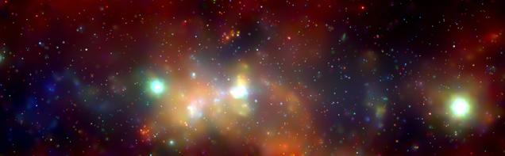

Dimensions – 20,000 light years across

Diameter: 100,000 light years Thickness: 15,000 light years thick

Nebulae – interstellar cloud of dust and gas – may form stars

Elliptical – contain little dust and clouds

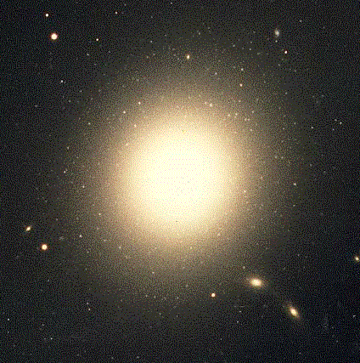

Spiral – arms spiral outward in a counterclockwise direction

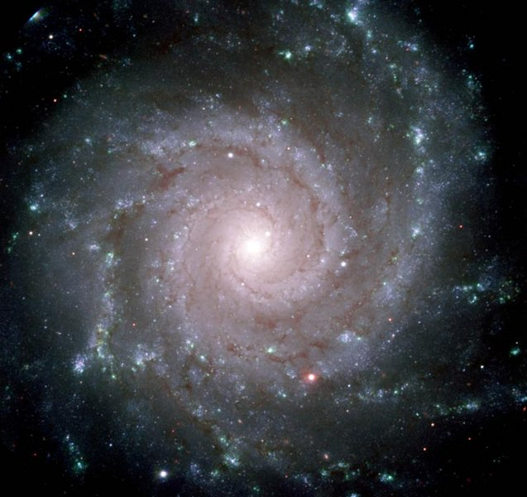
Irregular – appear chaotic – no form or pattern

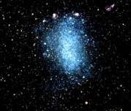

Star clusters – stars that are gravitationally attracted to each other

open – found within the same plane of an arm of a spiral galaxy

globular – spherical groups of stars within a few light years of each other

binaries – two nearby stars that revolve around a common center.

Constellations - is a group of stars visibly related to each other in a particular configuration.

Size of stars –

Medium – from one-tenth to ten times the size of the sun

Giant – 10 to 100 times as wide as the sun

Supergiants – up to 1000 times the width of the sun!

White dwarfs – smaller than the earth, maybe as wide as a continent

Neutron stars – some are only 16 km or 10 miles wide

Composition

H – 60 to 80%

He – together with H makes up 98-99% of mass

Temp. – 6000 degress C at surface/ 15 million degrees C at the core

Apparent magnitude – the brightness of a star when viewed from earth

Absolute – amount of light a star actually gives off

H-R diagram (pg. 70) relates the absolute magnitude to the star’s temperature

Parralax – refers to the apparent change in position a star makes in the sky (due to Earth movement)

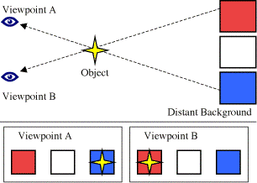

Magnitude – (light-years) – the distance from earth to the star

Spectral shift – if the observed color show red/blue shift?

Nova – a nuclear explosion occuring on the surface of a star.

Supernova – explosion of a star that produce extremely bright objects made of plasma – few months of life.

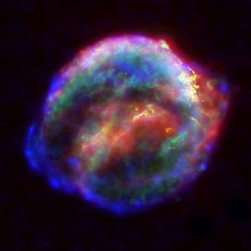

Corona – outermost layer of the sun’s atmosphere

Chromosphere – middle layer of the sun’s atmosphere

Photosphere – innermost layer of the sun’s atmosphere

Core – the center of the sun

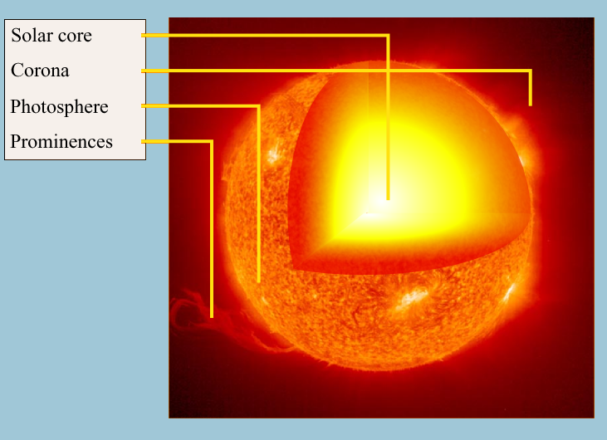

Prominences – violent solar storm on the sun; bright arches/loops of gas

Solar flares – bursts of light on the sun’s surface

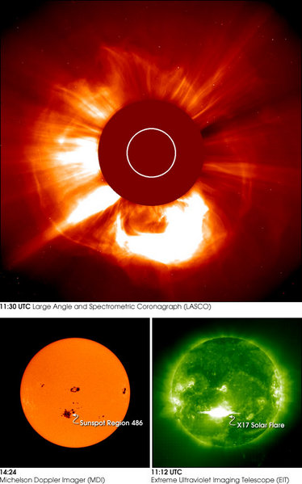

Solar wind – continuous stream of high energy particles released into all directions from the corona.

Sunspots – dark areas on sun’s surface.

