I. Weather – atmospheric conditions for a short period of time

Climate – general trends in temperature/rainfall for a region over along period of time.

II. Factors causing weather.

1. Radiant energy – energy heating the earth from the sun.

A. Heat transfer over the earth.

1) Conduction – transfer of heat by particle motion

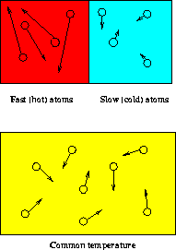

2) Convection – transfer of heat by fluid movement

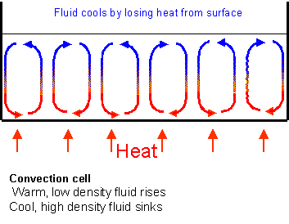
3) Radiation – transfer of heat energy by waves

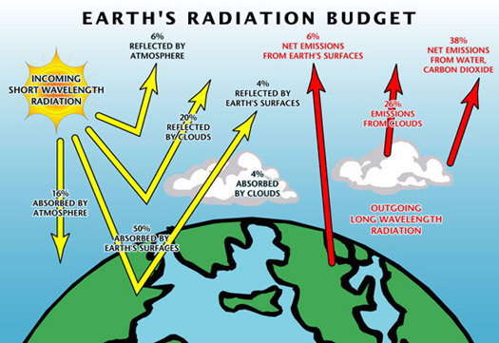

B. Greenhouse effect and temperature.

Carbon dioxide and other gases absorb infrared rays that are reflected off of the earth’s surface. This keeps the heat near the earth and creates a “heat blanket.”

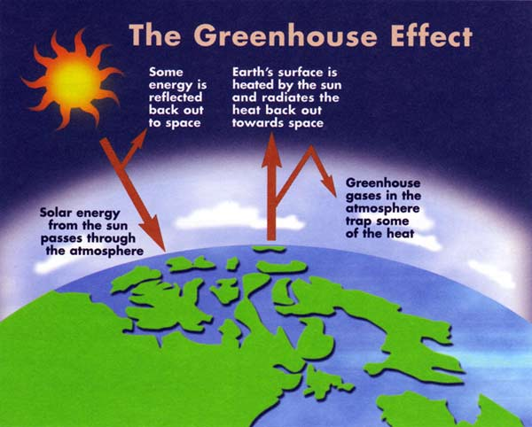

2. Air pressure is affected by:

a. Temperature – because fluid density decreases as temperature increases; regions of higher temperature are usually lower in pressure.

b. Water vapor – because water is less massive than other gases, moist air is less dense than dry air – less pressure is then exerted.

c. Elevation – as elevation increases, air gets thinner (fewer air molecules) – pressure decreases.

Barometer – device used to measure atmospheric pressure.

3. Winds

A. Air currents – move from a high pressure area to a low pressure area producing winds.

1) Local winds

a) land breeze – flow of air from land to sea.
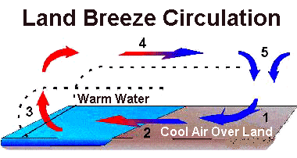

b) sea breeze – flow of air from sea to land.
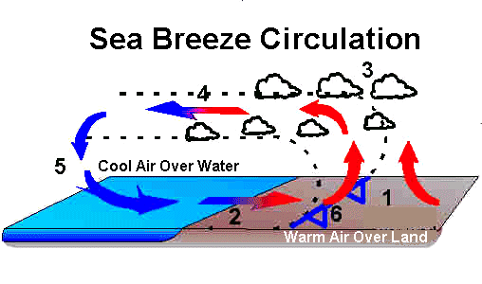

c) monsoon – a large ocean to land wind carrying very moist air.

2) Global winds

a) Coriolis effect – the turning of the Earth appears to make air and water turn to the right (north of equator) and to the left (south of the equator).

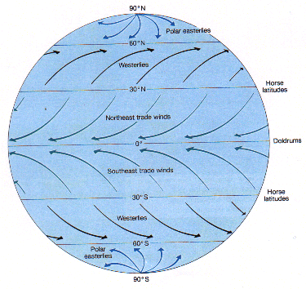

b) doldrums – heating causes air to expand; little air movement; lots of rainy weather.

c) trade winds – as the warm air from the equator rises and sinks, the Coriolis effect deflects it to the west providing a wind pattern for sailors.

3) jet stream – a narrow belt of strong wind near the top of the troposphere; separates the cold polar air of the north from the warmer tropical air of the south.

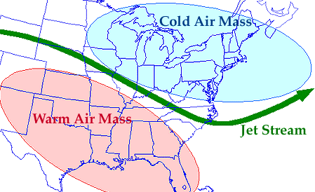

anemometer – a device used for measuring wind speed

4. Water moisture

a. relative humidity – amount of water vapor in the air at a certain tempertaure.

III. Clouds

1. cirrus – found before cumulus move in; associated with fait weather; located 6-12 km above surface)

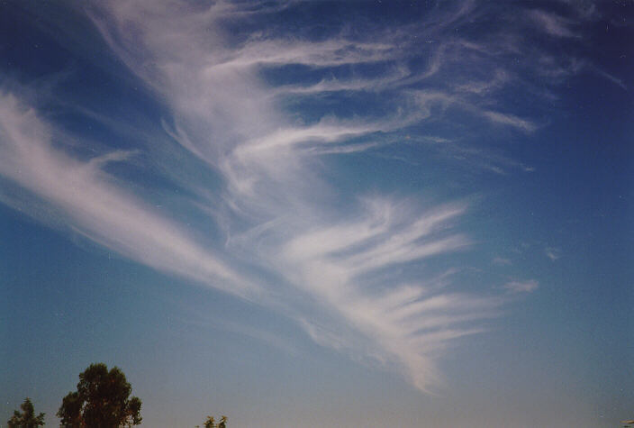

2. cumulus – puffy white clouds that can become thunderstorms (approx. 2-5 km above)

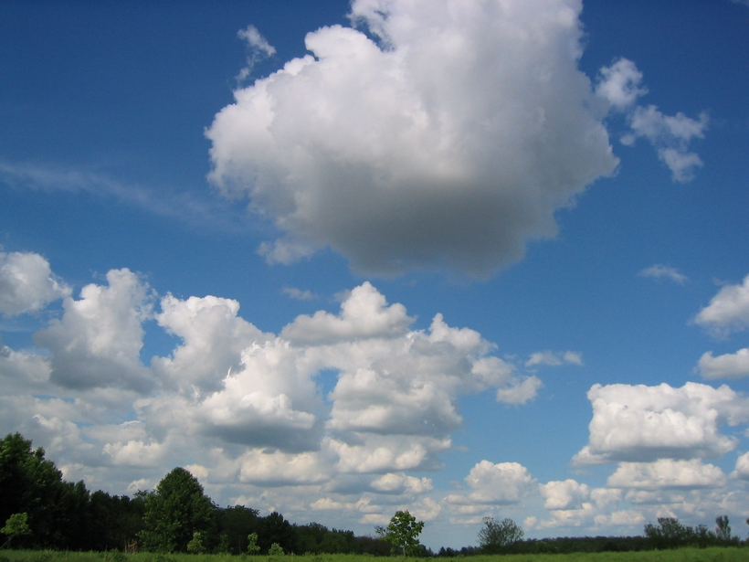

3. stratus gray with a flat, smooth bottom (approx. 2.5 km)

a. rain – when droplets of water condense in cloud; become too heavy and fall.

b. snow – droplets that freeze in the cloud before falling.

c. sleet – droplets freeze while they are falling to the surface.

d. hail – when winds in the clouds allow droplets to continually rise and fall within cloud; each time new droplets freeze to it creating hailstones.

IV. Air masses

1. Front

a. cold front – when a cold air mass pushes underneath a warm air mass.

b. warm front – when warm air mass moves over a cold air mass.

c. occluded front – when cool air overtakes cold front and pushes warm air upward.

d. stationary front – when warm air meets cold air and there is no movement.

V. Storms

1. rainstorm and snowstorm – occurs when two different fronts collide (warm meeting cold)

2. thunderstorm – when cold air moves in to meet warm air.

3. hurricane – low pressure area containing rising warm air formed over tropical regions.

4. tornado – formed when cold air and warm air meet over flat area; low pressure at the bottom; as air rises, spinning takes place.

VI. Weather Maps

1. isotherms – lines that connect areas of equal temperature.

2. isobars – lines that connect areas of equal pressure.

