Energy for the Future

I. Solar Energy

- Each second the sun radiates 10²⁶ W into space.

- The problem with using solar energy is its relatively low concentration on the earth’s surface.

- Not as cost effective as using fossil fuels.

II. Hydroelectric Power

A. Generates 8% of American power

1. No gaseous emissions like carbon dioxide or nitrogen dioxide

2. In some countries it contributes one third of the nation’s power

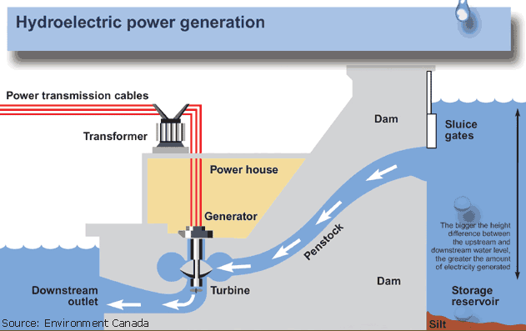

B. Disadvantages:

1. Many rivers in the United States cannot be dammed, and those that can be already are.

2. Threat to marine life because of the drastic change in the aquatic ecosystem.

3. Also possible dam failure and the lack of dams being aesthetically pleasing.

III. Wind Power

A. Provides 1% of all power in California – a little more than a half million homes

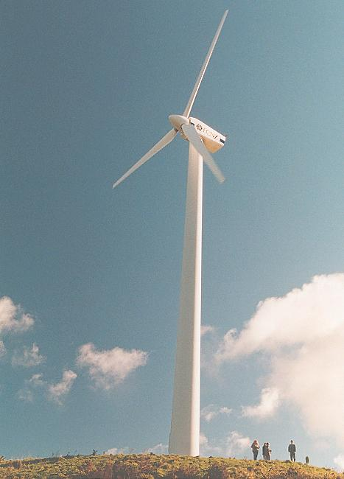

B. Need to construct many wind turbines to generate significant power.

C. They are also not aesthetically pleasing, plus they operate intermittently.

IV. Solar Thermal Energy

A. Solar Power Towers

1. Towers that focus sunlight onto a single area.

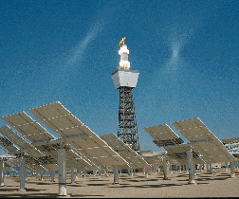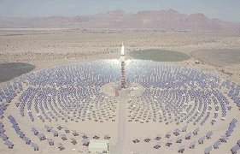

2. Heat warms up a solution that turns water to steam.

3. Turbine generates power which can be stored or distributed.

B. Parabolic Troughs

1. Uses a similar process to focus light onto an oil that runs through a pipe in a trough.

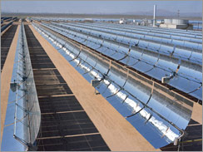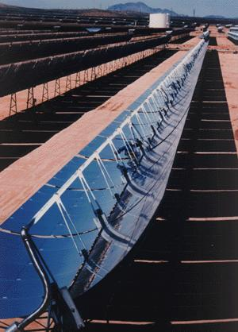

2. The oil is used to heat water, which is then used to activate a turbine.

3. Can produce 350 MW vs. a normal coal plant that operates at 1000 MW.

C. Dish/Engine

1. Uses a collector to reflect light onto a receiver.

2. The receiver then becomes the heat source for a conventional turbine

3. These systems can be hybridized to use other fuels.

VI. Biomass

A. Plants and vegetation can be burned to release the energy contained within them.

B. Liquid fuels such as ethanol can also be produced from plants like corn or sugar cane.

C. The major drawback is the significant amount of land required to grow such large volumes of plant material.

VII. Geothermal Power

A. Heat contained within earth’s surface is either directly channeled to turbines or is used to produce steam (geysers) that can turn turbines.

B. In California, enough geothermal energy is used to provide electricity for nearly 2 million homes.

C. Limited availability – only areas near volcanoes or earthquake activity (seismic areas) are suitable.

VIII. Conservation

A. Despite the advances in fuel technology, conservation is still the key.

B. Space heating, appliances, and water heating use the greatest amount of electricity in home usage.

Problems: 1, 2, 3, 5, 6, 15, 16, 26, 27

