Energy

I. Basic Thermodynamics

A. First Law of Thermodynamics – energy can be neither created or destroyed; only transferred between the system and its surroundings.

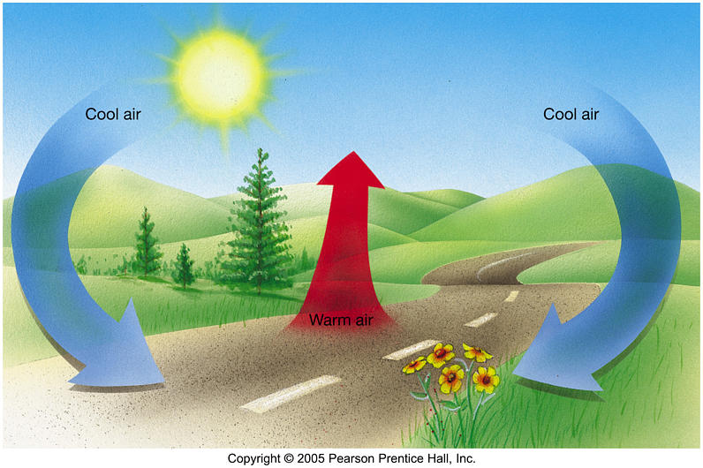

B. Energy can be converted from one type to another:

1. The energy stored in the bonds of gasoline particles can be burned to run a car.

2. The stored energy in our body fat can be broken down to help people run.

C. It is impossible for a machine to create more energy than it uses.

D. Efficiency is a measure of how much energy is actually used from an energy source.

II. Entropy

A. Entropy is another word for disorder

B. Any reaction that happens spontaneously will create more entropy, or disorder.

C. Think of a bag of marbles – will all of the different colored marbles stay together or will they be spread apart and mixed up?



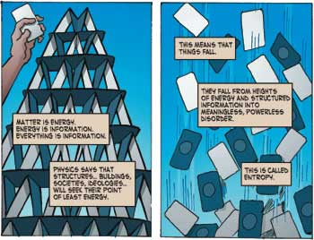

III. What does Energy mean?

A. Energy is the ability to do work.

1. Units are the joule (J)

2. Older units are the calorie – the energy needed to raise 1 g of water by 1 degree Celsius.

3. One calorie = 4.184 joules

B. Power – is a measure of the energy used in a period of time. It is measured in watts (W).

IV. Heat vs. Temperature

A. Heat is a measure of the total amount of energy in an object.

B. Temperature is a measure of the average energy of particles at a particular point.

V. Energy We Use

A. Most energy used by humans are in the form of hydrocarbons – compounds that contain hydrogen and carbon. Burning these compounds releases energy and gases.

1.

2.

3.

B. Common hydrocarbons are natural gas, coal, propane, and oil.

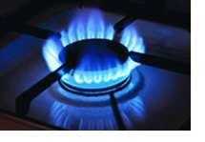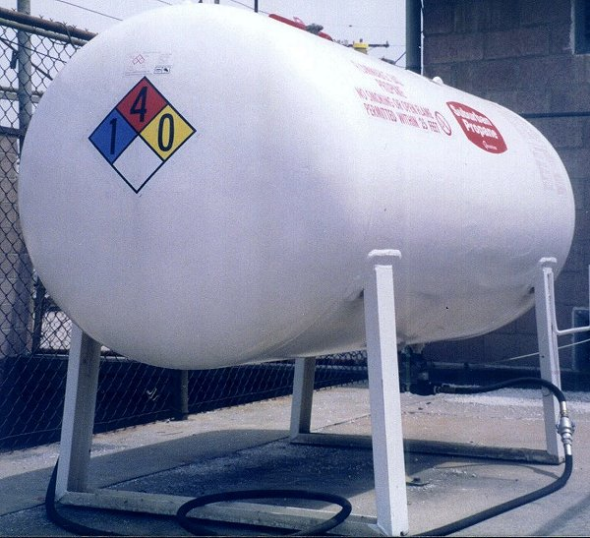

VI. Environmental Issues with Energy Use

A. Smog is made of the following gases:

1. Carbon monoxide (CO):

a. makes it harder to breathe

b. heart must work harder because it prevents oxygen from traveling in the blood.

2. Nitrogen oxides (NO and NO₂):

a. give the brown/orange color to air on hazy days

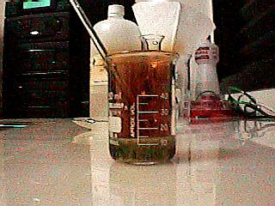

b. creates burning sensation in lungs and eyes

c. catalytic converters in cars aim to reduce the levels of these compounds.

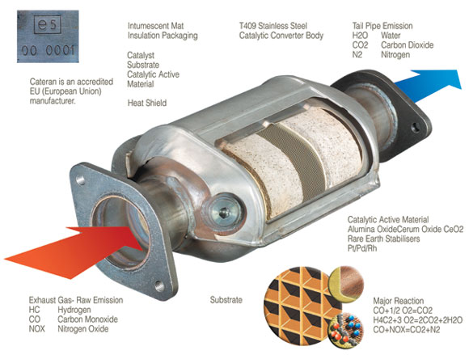
B. Acid rain and the environment

1. Primary cause is from sulfur that is released from factories:

2. Reacts with water in the air to create sulfuric acid:

3. In turn the acid component of rain can:

a. cause damage to lakes and streams, as well as the fish and vegetation that lives in them.

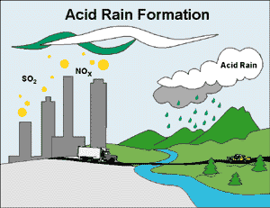

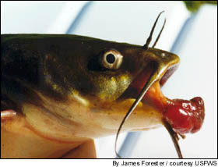

b. destroy the paint or other protective coating on buildings.

c. lower the ability for trees to grow and fight diseases.

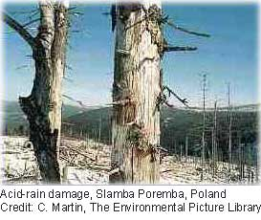

C. Global warming – carbon dioxide prevents heat from leaving the earth’s surface.

