I. Classifying Matter

- Substance – a pure form of matter; all particles are identical

Examples – glass, water, table salt

- Properties

a. Volume – the property of all matter taking up space.

b. Mass – the amount of matter (stuff) contained within a substance.

II. Phases of Matter

1. Solid – the state of matter where all particles are compacted around one another. Solids have a definite shape and a definite volume.

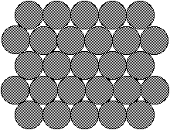

melting – solid to liquid change of state

freezing – liquid to solid change of state

2. Liquid – the state of matter where particles can move somewhat freely. Liquids have no definite shape but a definite volume.

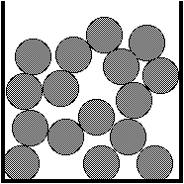

boiling (vaporization) – liquid to gas change of state

condensation – gas to liquid change of state

3. Gas – the state of matter where particles can freely move all around each other. Gases have no definite shape and no definite volume.

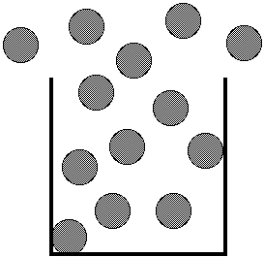

sublimation – solid to gas change of state

deposition – gas to solid change of state

4. Plasma – only exists at very high temperatures; it is a fluid of charged particles.

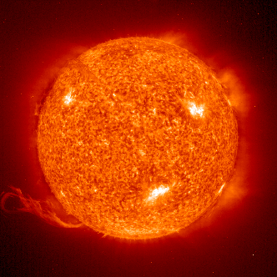



III. Mixture

1. Definition – any combination of two or more distinct types of matter.

a. Solution – a specific liquid mixture in which one or more materials are dissolved in a liquid.

1) Solute – the material that is dissolved in solution. (Sugar, salt)

2) Solvent – the material that dissolves the solute. (Water)
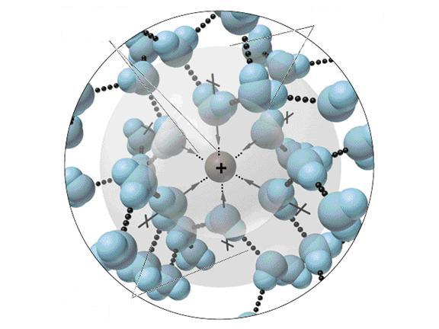

b. Alloy – a mixture of two or more metals with each other to create a new metal. (Steel, brass)

2. Saturated Solution – a solution in which no more solute can be dissolved.
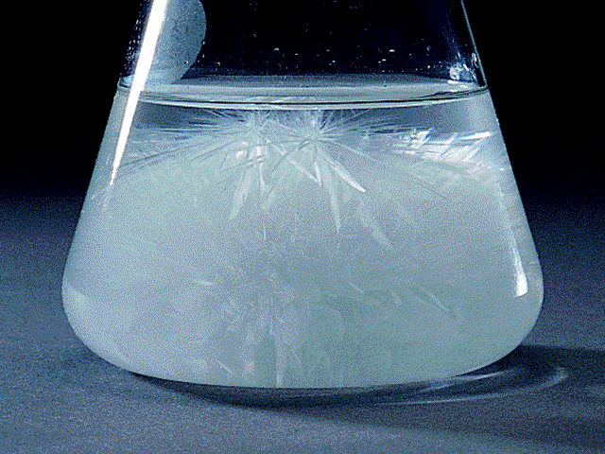

3. Unsaturated Solution – a solution which has room for more particles to be dissolved in it.

4. Compounds – combinations of two or more elements to create a new type of matter. (Sodium added to chlorine makes sodium chloride).

Smallest particle – molecule

5. Elements – the smallest types of matter that are unique; there are 92 naturally occurring elements.

Smallest particle – atom

IV. Properties of Solids

A. Density – is the relationship between mass and volume; density = mass divided by volume

- float vs. sink – objects that are more dense will sink in objects that are less dense.

- units – grams per cm³ or grams per mL (mass units divided by volume units)

3. describes how tightly packed the molecules are in a substance.

Generally: solids > liquids >>> gases

B. Hardness – is a measure of an object’s resistance to scratching. For minerals, Moh’s scale is used.

C. Elasticity – is a measure of an object’s ability to return to its original shape.

D. Metals:

- malleability – a measure of a metal’s ability to be bent or reshaped.

- ductility – the ability for a metal to be drawn into a wire

- tensile strength – the measure of how much pull a wire can withstand before it snaps.

- magnetism – the ability for the particles in a metal to create a magnetic field that can attract/repel other metals. (Iron – “ferrous metals”)
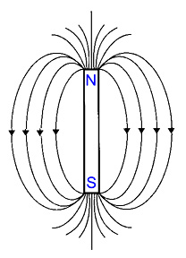
V. Fluids – anything that has no definite shape

A. Density

1. Effect of Temperature on Liquids – as temperature increases, density decreases because molecules get farther apart (exception – water at low temperatures)

2. Gases – density is dependent on temperature and pressure of the gas.

B. Buoyancy – measure of the upward pressure a fluid exerts on an object.

1. Archimedes’s Principle – the force exerted on an object in a liquid is equal to the weight of the fluid it displaces.

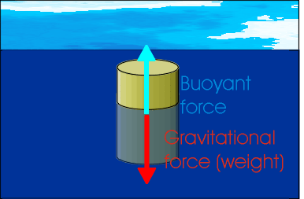

2. sink vs. float – an object will sink if its buoyant force is less than the object’s weight.

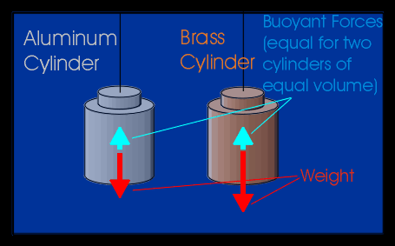

C. Gases

1. Effect of Temperature – As the temperature of a gas increases; so does its volume (Charles’s Law).

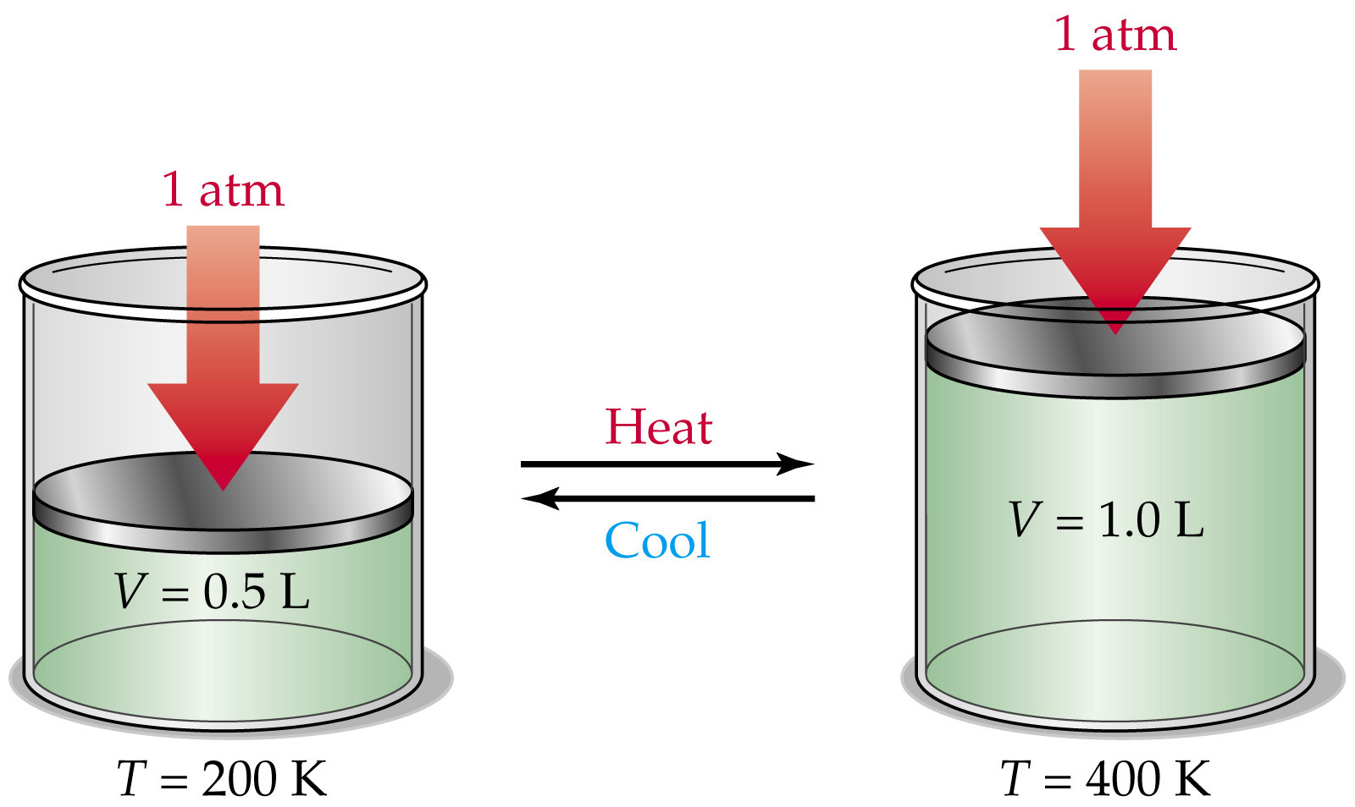

2. What is Pressure? – is a measure of the number of particles colliding with the surface of a material.

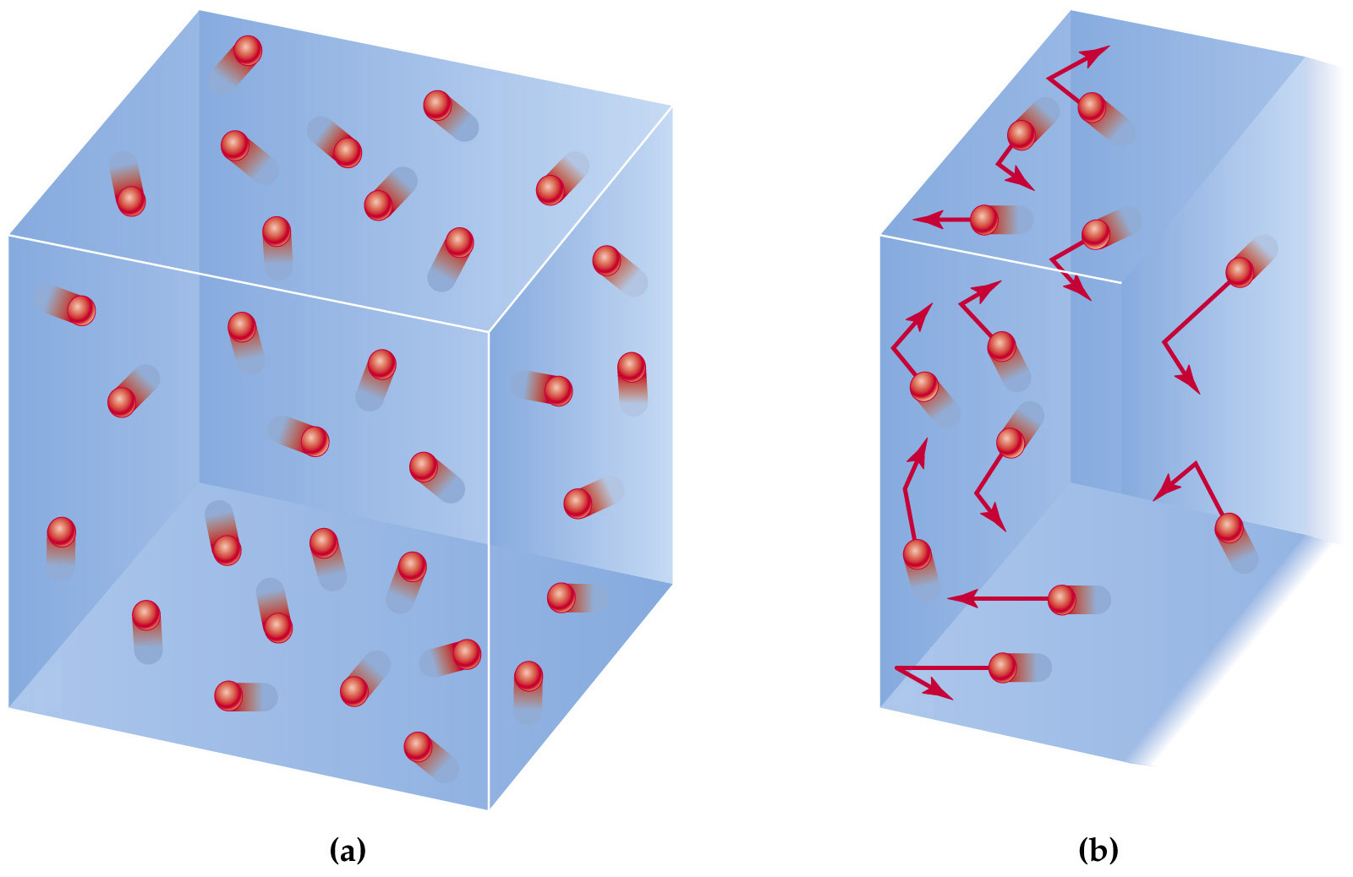

3. Effect of Pressure – As pressure increases, the volume of a gas decreases (Boyle’s Law).

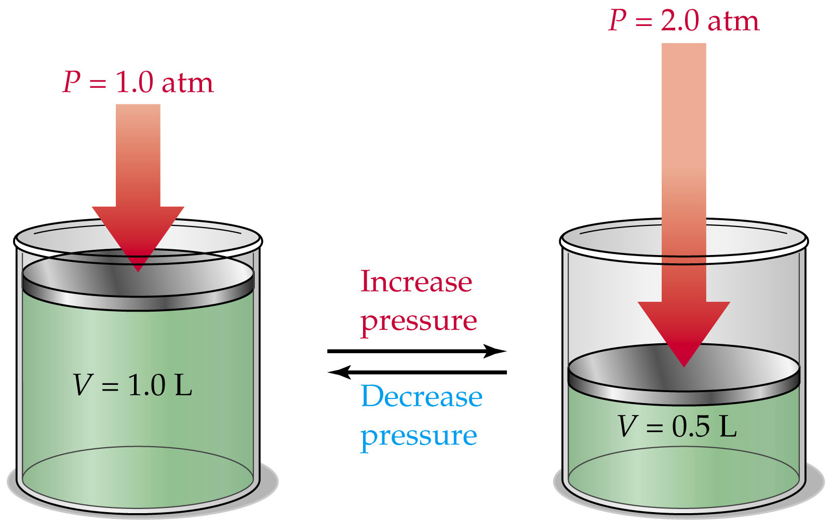

D. Viscosity of Fluids

1. What is it? Is a measure of a substance’s resistance to flow.

2. What determines a fluid’s viscosity? The larger the molecules in a fluid, the more the molecules collide with each other and prevent them from moving (flow).

3. Relationship to temperature

a. liquids – as temperature increases, viscosity decreases because the liquid molecules can move faster.

b. gases – as temperature increases, viscosity increases because the molecules collide with each other more; preventing movement (flow).

