I. Nuclear Reactions

A. Fission – The splitting of atoms into smaller elements to generate energy

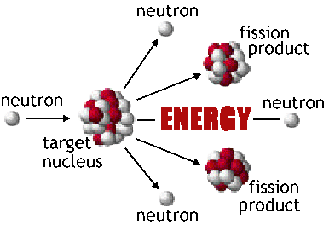

B. Fusion – The combining of atoms together to make larger elements and create energy. More energy created during fusion than fission.

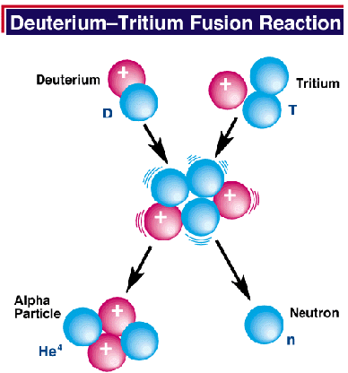

II. Nuclear vs. Chemical
Chemical Nuclear

A. Particles involved: electrons protons/neutrons

B. Energy involved very little change millions of times
greater energy change

C. Conditions low temperatures high
temperatures only

D. Why? Elements want to nuclei are
swap electrons unstable

III. Radioactivity

A. What makes a nucleus unstable? A large ratio of neutrons to protons OR nucleus could be too large.

B. What is radioactive decay? – the process by which a nucleus emits radiation (energy) and/or a particle to stabilize itself.

1. alpha - the largest particle released; cannot
penetrate paper; 2 protons/2 neutrons

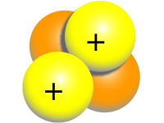

2. beta - another name for electron; cannot
penetrate thick clothing; can cause burns

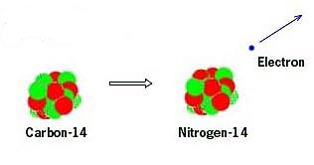

3. gamma - can only be blocked by dense material like lead; not a particle (ray); can cause death.

IV. Half-life – the time it takes for one-half of a radioactive substance to decay; range from seconds to years depending on the particle.

V. Nuclear Reactions for energy

A. elements used – uranium and uranium/plutonium combinations.

B. nuclear waste – takes long time to decay/currently stored at the location of the reactor.

VI. Medicine

A. Tracers – use radioactive material to track the progression of medicine throughout the body.

B. PET Scans – use the reactions of positrons (like beta particles) and atoms in the brain to monitor brain activity.

VII. Dating Artifacts

The amount of decayed material can be measured in a particular sample, and compared to the amount of material originally present (like a bone) to determine age.

VIII. Why is radiation dangerous?

Radiation can cause mutations in the genetic material of most animals. Long term exposure causes burns, then sickness, finally death or cancer.

IX. Detecting radiation

A. Background radiation – all of the naturally occurring radiation present in room and atmosphere.

B. Cosmic radiation – radiation you are exposed to from celestial objects (sun, stars, black holes, etc.)

C. Geiger counter – an instrument that clicks whenever radioactive material is present.

X. Mass Defect and Nuclear Binding Energy

A. Mass defect – difference in mass between a nucleus and the sum of each of its individual particles.

B. The reason why the individual particles have a greater mass is because some of it is converted to nuclear binding energy – the “glue” that holds the nucleus together.

XI. Nuclear Equations

Examples:

The sum of the mass number and atomic number must be the same on both sides of the arrow. What is the difference between the masses 15 and 4? The atomic numbers 7 and 2?

Here the difference between the two numbers are a little tricky because of the beta particle’s –1.

Can you fill in the missing numbers?

