I. Light as Energy

A. Speed – 2 998 000 000 meters/second or 186 000 miles/second

B. Method of travel – as a continuous wave

C. Visibility:

1. individual waves are not visible

2. reflected/absorbed light is perceived as color

II. What makes light?

A. Photoluminescence – any process which uses a chemical reaction to produce light (phosphorescence – a glow stick)

B. Fluorescence – materials that emit visible light when a
higher energy light (ultraviolet) is shined upon them.

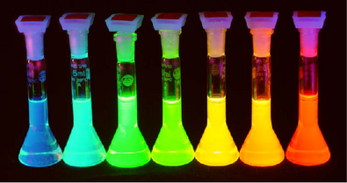

C. Incandescence – light is produced from the warming of an object (light bulb filament)

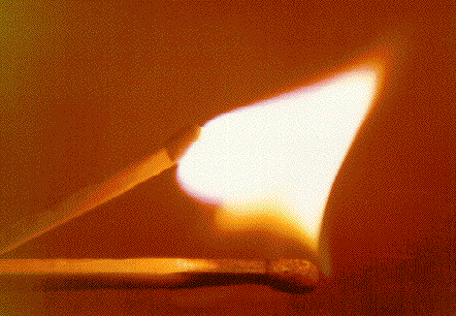

III. The Electron and light:

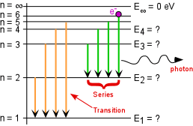
IV. The Electromagnetic Spectrum:
Is a chart that sorts all of the types of electromagnetic radiation by wavelength

A. Electromagnetic radiation is:

1. energy that travels as a wave

2. moves at the speed of light

B. Light has a wavelength that falls between X-rays (shorter than light) and microwaves (longer than light)

V. Polarization

Occurs when a material only allows light at a certain orientation to pass through; therefore blocking most other light.

VI. Color

A. The 9 colors:

Infrared (invisible) red, orange, yellow, green, blue, indigo, violet, ultraviolet (invisible)

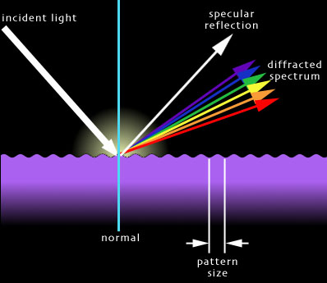

B. Why is a shirt blue under sunlight?

The shirt absorbs all colors of the light except blue, which is reflected back to your eye.

C. Subtractive Color Process

Dyes subtract out the colors you don’t see and reflect the colors you do see.

D. How do we see colors other than ROY G BIV?

Most colors are a blending of a variety of colors in the rainbow:

All colors: white no colors: black

E. Television sets

Use red, green, blue (primary colors) in varying ratios to produce all other colors

F. Plants and Chlorophyll

Chlorophyll absorbs all colors except green.

