I. Classifying Matter

- Substance – a sample of matter that is pure; all particles are the same kind.

Examples – glass, water, table salt

- Properties

a. Volume – the property of all matter taking up space.

b. Mass – the amount of matter (stuff) contained within a substance.

II. Phases of Matter

1. Solid – the state of matter where all particles are compacted around one another. Solids have a definite shape and a definite volume.

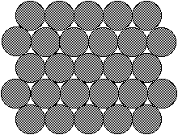

melting – solid to liquid change of state

freezing – liquid to solid change of state

2. Liquid – the state of matter where particles can move somewhat freely. Liquids have no definite shape but a definite volume.

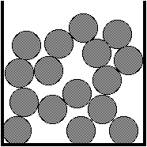

boiling (vaporization) – liquid to gas change of state

condensation – gas to liquid change of state

3. Gas – the state of matter where particles can freely move all around each other. Gases have no definite shape and no definite volume.

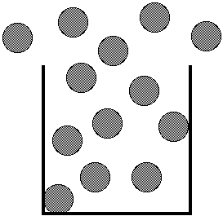

sublimation – solid to gas change of state

deposition – gas to solid change of state

4. Plasma – only exists at very high temperatures; it is a fluid of charged particles.

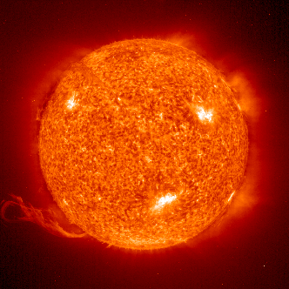
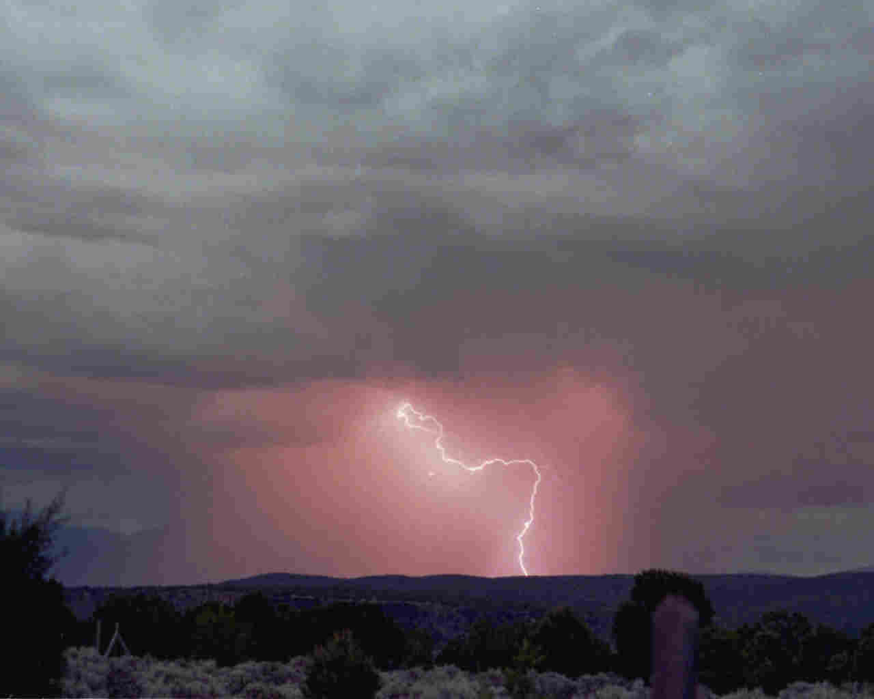
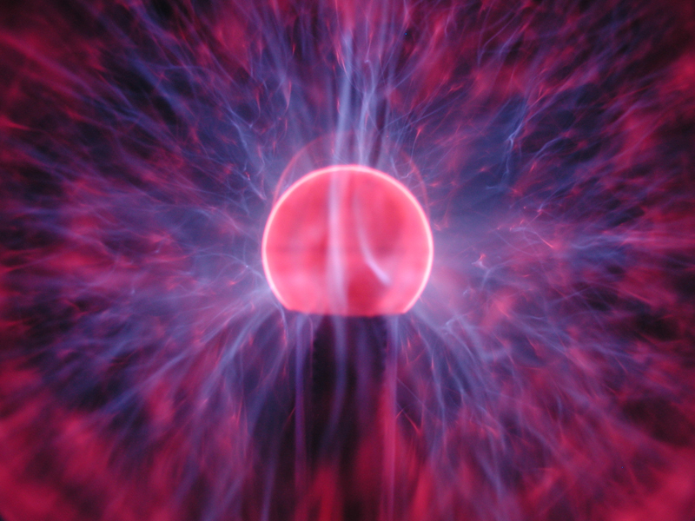

Stars like our sun are made of plasma.

III. Mixture

1. Definition – any combination of two or more distinct types of matter.

a. Solution – a specific liquid mixture in which one or more materials are dissolved in a liquid.

1) Solute – the material that is dissolved in solution. (Sugar, salt)

2) Solvent – the material that dissolves the solute. (Water)

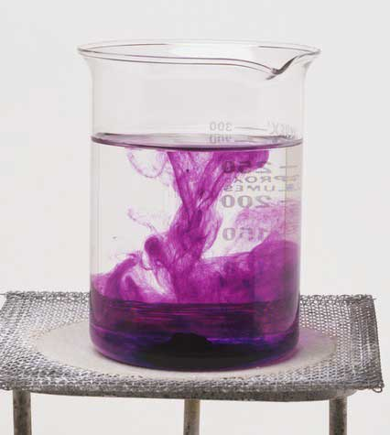

b. Alloy – a mixture of two or more metals with each other to create a new metal. (Steel, brass)

2. Saturated Solution – a solution in which no more solute can be dissolved.

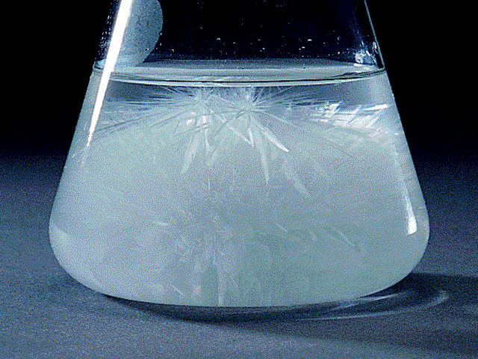

3. Unsaturated Solution – a solution which has room for more particles to be dissolved in it.

4. Compounds – combinations of two or more elements to create a new type of matter. (Sodium added to chlorine makes sodium chloride).

Smallest particle – molecule

5. Elements – the smallest types of matter that are unique; there are 92 naturally occurring elements.

Smallest particle – atom

