Models of the Atom

I. Atomic mass –

1. Def. – a property all atoms have because atoms make up matter. The mass is equal to the sum of the masses of all the particles in an atom.

II. Atomic Structure

I. Nucleus – where most of the mass in the atom is contained.

a. protons – positively charged particles located in the
nucleus. Mass is slightly less than neutron.

b. neutrons – particles with no charge also located in
the nucleus. Most massive particle in the atom.

2. electrons – negatively charged particles that travel freely around the nucleus. The mass of 1800 electrons is equal to the mass of 1 proton.
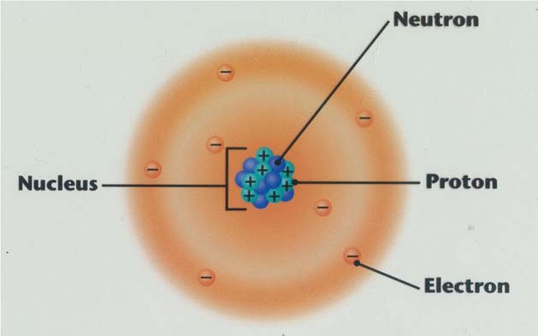

3. Atomic Number – the number of protons in an atom.

4. isotopes – atoms of the same element that have different numbers of neutrons. Because the neutron is so massive, isotopes have very different masses.

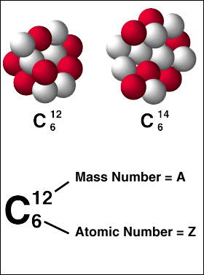

III. Periodic Table

1. period – another name for the rows on the periodic table. There are seven periods.

2. family – another name for the columns on the periodic table. There are 18 families, and they are also called groups.

3. chemical symbols – the one or two letter combinations used to represent an element in formulas and equations for reactions.

4. atomic mass – because the electrons have little mass, the atomic mass is approximately equal to the sum of the protons and neutrons.

5. atomic number - it is represented on the periodic table by the large whole number in each element box.

6. electron configuration – is a detailed way of showing where the electrons are located around the nucleus.

7. Noble gases – Group 18 on the periodic table. These elements do not react with other elements.

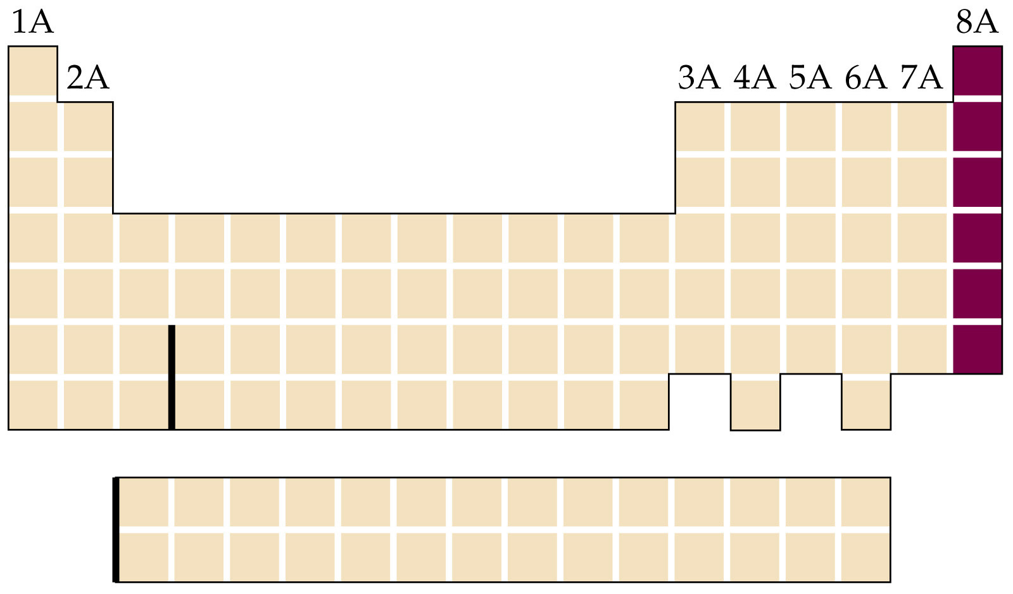

8. Halogens – Group 17 on the periodic table. These elements are nonmetals, and are the most reactive elements.

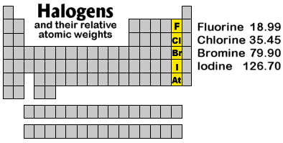

IV. Atomic model

1. energy levels – there are seven of them; the more energy an electron has, the farther away from the nucleus it will be located. The energy level of an electron corresponds to the period it is in.

2. number of electrons in each level – can be found by the energy level (n) as 2n².

3. Neutral atom has equal numbers of protons and electrons; if unequal they are called ions.

