Describing Motion

I. Graphing

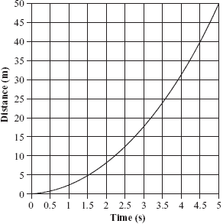

A. independent variable – is placed on the x-axis. This variable is known in advance.

B. dependent variable – is placed on the y-axis. This is the variable that is being tested.

II. Motion

1. Occurs whenever the position of an object is changing.

2. Described in terms of how fast the object is moving, direction, and whether the motion is constantly changing or not.

3. Reference objects

a. used as a point of reference against which an object’s motion is measured.

b. an object that is moving in one frame of reference may not be moving in another.

Example: a person on board a train with reference to a passenger or to someone outside.

III. Speed

1. Describes how fast an object is moving in relation to a reference object.

2. Velocity – distinguished from speed because it indicates a direction.

3. Many objects can have the same speed, but different velocities. (Ants moving outside an anthill).

4. Formula:
where s is speed, d is distance, and t is time.

What is the speed of a biker who travels 45.0 km in 6.2 hr?

What is the distance traveled by a car moving at 85 km/hr for 2.5 hr?

How much time does it take a person running 7.0 km/hr to travel 18.3 km?

5. Constant speed – an object that does not change its speed.

a. This could indicate the object is not moving at all or it always moves the same distance over identical time periods.

b. Graph: 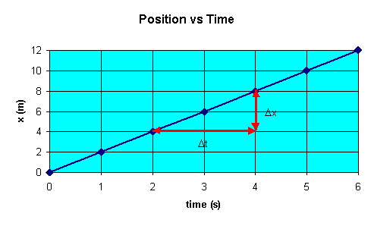
6. Average speed – the total distance traveled during the total time of a trip.

7. Instantaneous speed – the speed at an exact moment in time. This is what a speedometer tells you.

IV. Acceleration

1. Any situation where the velocity of an object is changing due to an increase in speed/decrease in speed or change of direction.

2. Formula:

Ex. A person walks from 2 m/s to 8 m/s in 5 seconds. What is the person’s acceleration?

A train slows from 23.0 m/s to rest in 6 s. What is the train’s acceleration?

3. Graphs:

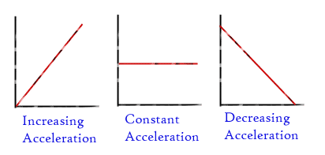

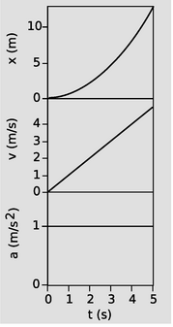

4. Freefall is a special acceleration that is due to gravity. Objects in freefall fall a rate of 10 m/s².

5. Positive acceleration indicates “speeding up” while negative acceleration indicates “slowing down.”

6. Terminal velocity is the point at which air resistance prevents an object from accelerating (falling faster).

