I. Newton’s First Law of Motion

A. Force – is any push or pull that changes an object’s state of motion.

B. Forces can be created by:

1. gravity
2. motion of other matter
3. bodily motion

C. Inertia – the mass of an object is directly related to its ability to change its state of motion.

D. Newton’s First Law – An object at rest tends to stay at rest unless acted upon by an outside force.

E. Only forces have the ability to change the motion of an object. Constant speed is not a change in motion!

II. Newton’s Second Law of Motion

A. The acceleration of an object is equal to the force applied to it divided by its mass.

1. An object moving at constant speed requires no force (zero acceleration)

2. Forces cause acceleration; masses resist acceleration.

B. Problems:

1. What force is needed to speed a 2500 kg car from rest to 20.0 m/s in 5.0 seconds?

2. If a person weighs 450 N, what is the mass?

C. 4.448 N = 1 pound; so a 150 lb adult has a weight of 667.2 N

D. The sum of all the forces acting on an object is the net force on the object.

1. A net force not equal to zero means the object is accelerating
2. A net force of zero means the object is not accelerating, but not necessarily at rest either.

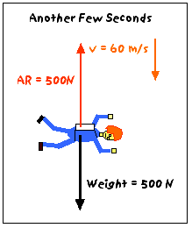

III. Newton’s Third Law of Motion

A. Forces must always occur in action-reaction pairs.

B. Often stated as “for every action there is an equal and opposite reaction.”

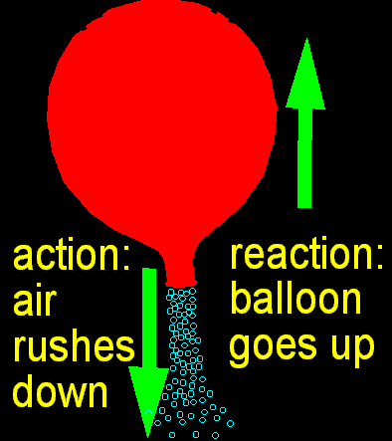

C. Why does the chair support you instead of your weight dropping you straight to the floor?

1. Force from you ON the chair
2. Equal, but opposite force from chair ON you

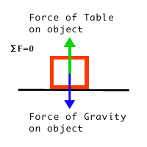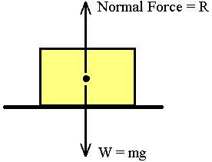

- The first and second law only apply to single
objects. The third law considers multiple objects at a time.

E. Action/reaction pairs do not cancel each other out because they act on different objects.

