Atoms, Elements, Molecules and Compounds (Ch. 18 and 19)

I. Atomic mass –

1. Def. – a property all atoms have because atoms make up matter. The mass is equal to the sum of the masses of all the particles in an atom.

II. Atomic Structure

I. Nucleus – where most of the mass in the atom is contained.

a. protons – positively charged particles located in the
nucleus. Mass is slightly less than neutron.

b. neutrons – particles with no charge also located in
the nucleus. Most massive particle in the atom.

2. electrons – negatively charged particles that travel freely around the nucleus. The mass of 1800 electrons is equal to the mass of 1 proton.
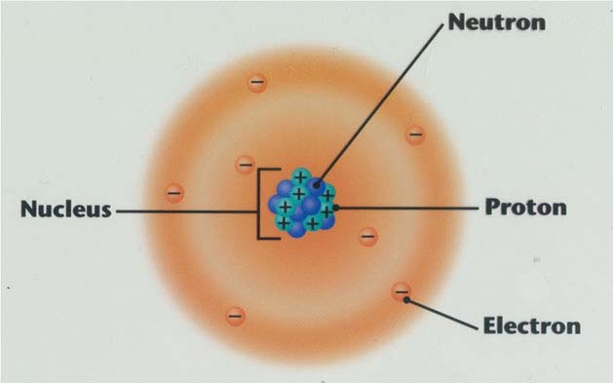

3. Atomic Number – the number of protons in an atom.

4. isotopes – atoms of the same element that have different numbers of neutrons. Because the neutron is so massive, isotopes have very different masses.

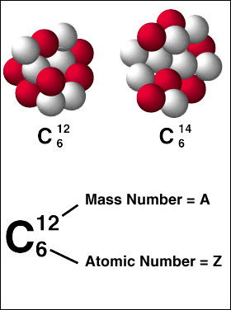

III. Periodic Table

1. period – another name for the rows on the periodic table. There are seven periods.

2. family – another name for the columns on the periodic table. There are 18 families, and they are also called groups.

3. chemical symbols – the one or two letter combinations used to represent an element in formulas and equations for reactions.

4. atomic mass – because the electrons have little mass, the atomic mass is approximately equal to the sum of the protons and neutrons.

5. atomic number - it is represented on the periodic table by the large whole number in each element box.

6. electron configuration – is a detailed way of showing where the electrons are located around the nucleus.

7. Noble gases – Group 18 on the periodic table. These elements do not react with other elements.

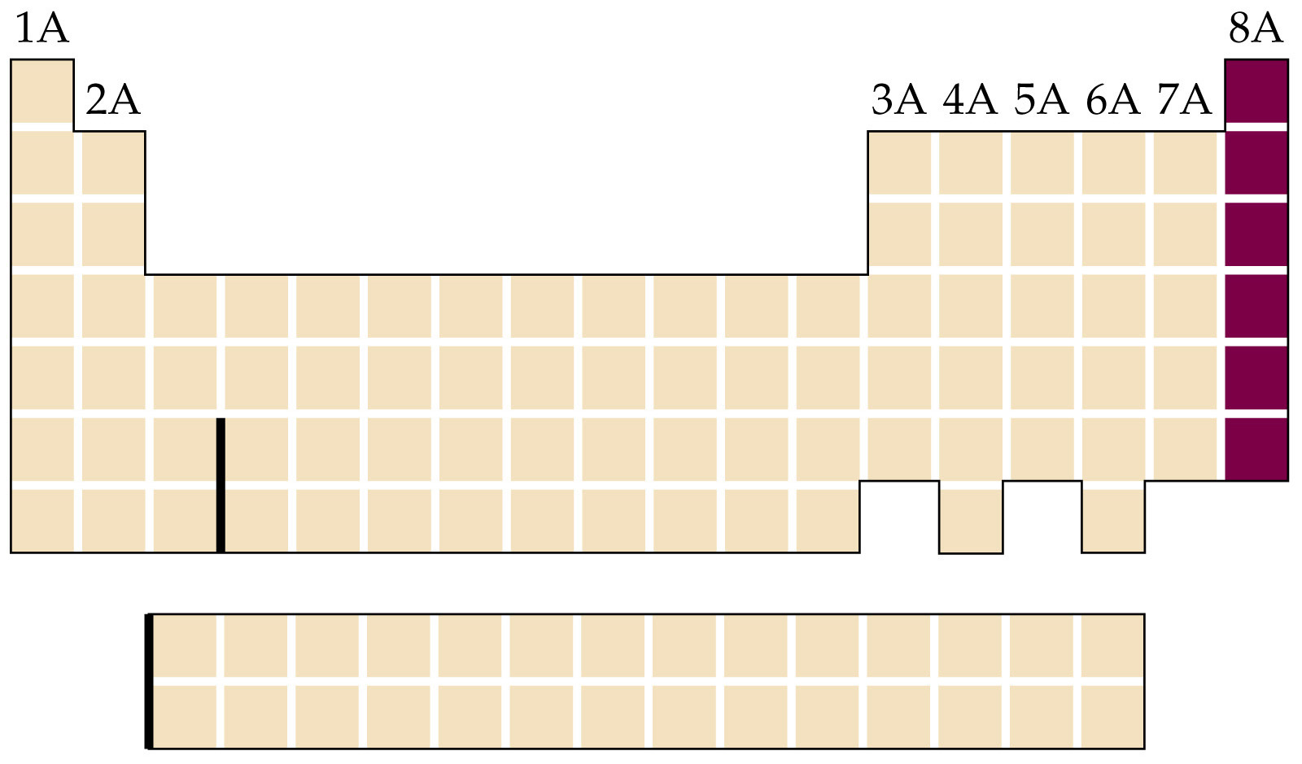

8. Halogens – Group 17 on the periodic table. These elements are nonmetals, and are the most reactive elements.

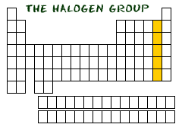

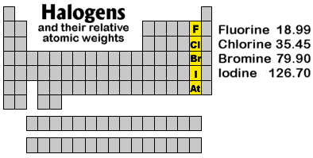

IV. Atomic model

1. energy levels – there are seven of them; the more energy an electron has, the farther away from the nucleus it will be located. The energy level of an electron corresponds to the period it is in.

2. number of electrons in each level – can be found by the energy level (n) as 2n².

3. Neutral atom has equal numbers of protons and electrons; if unequal they are called ions.
V. Compounds

A. Molecules – are the simplest particles of a compound that maintain the properties of that compound. They are made by combining two or more atoms of any elements.

B. Examples – H₂O NaCl C₆H₁₂O₆

K₂SO₄ TiO₂ SO₃

C. Classified as a substance because all molecules of the same compound have the same number of atoms of each element, and therefore the same properties.

VI. Chemical Formulas

A. Subscripts represent the number of atoms of that particular element.

B. Parentheses indicate that the elements inside are to be considered as one unit (called a polyatomic ion). Any subscript outside the parentheses must be multiplied by the elements inside to find the total number of elements.

C. Examples

K₂SO₄ 2 K 1 S 4 O = 7 atoms

C₆H₁₂O₆ 6 C 12 H 6 O = 24 atoms

Al(OH)₃ 1 Al 3 O 3 H = 7 atoms

(NH₄)₂Cr₂O₇ 2 N 8 H 2 Cr 7 O = 19 atoms

VII. Ionic Compounds

A. definition – are formed by ionic bonds; the unequal sharing of electrons between two atoms. In fact, one atom always gives it electrons to another element.

B. formed when the metallic elements in the compound give their electrons to the nonmetals. Metals always prefer to give; nonmetals prefer to take electrons.

VIII. Covalent Compounds

A. definition – are formed by covalent bonds; the equal or near equal sharing of electrons between two atoms. The only pure covalent compound is formed when two atoms of the same element bond with each other.

B. formed when nonmetals bond with other nonmetals.

IX. Molecular Weight

A. definition – the mass of all the atoms of a compound summed together.

B. Examples:

1. H₂S 1.01 + 1.01 + 32.1 = 34.12 formula units

2. C₃H₈O 3(12.0) + 8(1.01) + 16.0 = 60.08 formula units

3. Ba(NO₃)₂ 137.3 + 2(14.0) + 6(16.0) = 261.3 formula
units

4. (NH₄)₃PO₄ 3(14.0) + 12(1.01) + 31.0 + 4(16.0) =
149.12 formula units

X. Naming Compounds

A. Covalent – Use prefixes in front of the name of each of the elements.

1. N₂O₅ dinitrogen pentoxide

2. S₂Cl₂ disulfur dichloride

3. Cl₂O₇ dichlorine heptoxide

B. Ionic – give the name of the cation (metal or positive ion) followed by the name of the anion (nonmetal or negative ion)

1. BaCl₂ barium chloride

2. K₂SO₄ potassium sulfate

3. Ca(OH)₂ calcium hydroxide

