Electric Circuits and Power

1. Wire – straight line

2. Battery

3. Bulb 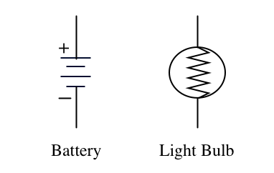

4. Switch

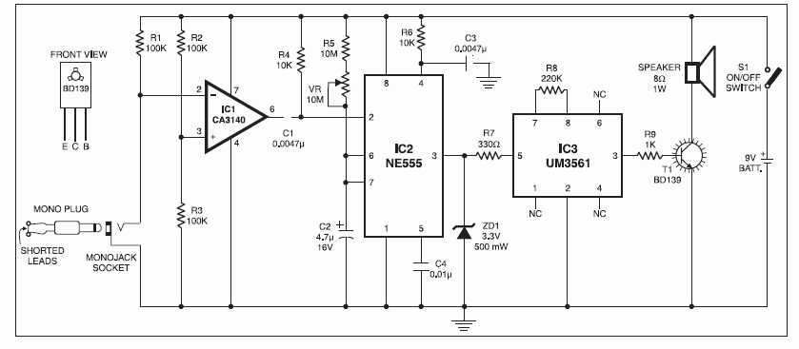
5. Resistance – is a measure of how easily electrical current moves through an object.

6. Voltage – is a measure of electrical potential energy; voltage differences represent energy that can be used to do work.

7. What is electric current?

Carries electrical energy and power as it flows through metal wires; it is dependent on voltage and resistance

I. Series and Parallel Circuits

- Series circuits contain only one path for current to flow.

B. The amount of current is the same at all places along the circuit.

C.
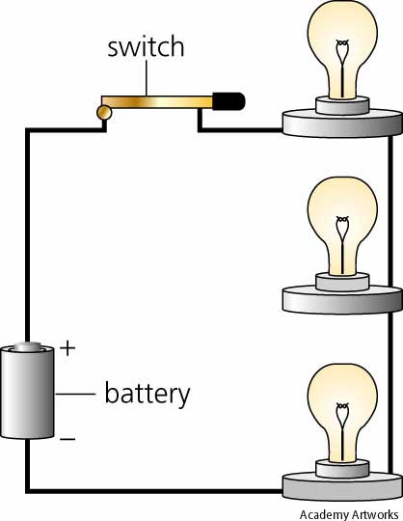

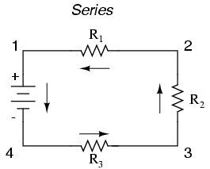

D. Total Resistance = Sum of individual resistances

R_{total} = R₁ + R₂ + R₃ + …

E. Every part of the circuit adds some resistance, even the wire and batteries.

- Voltage gets lower after each resistance. Therefore the total resistance in a circuit must consume all of the voltage.

II. Parallel Circuits

A. There are multiple paths for the current to flow through.

B. All of the current flowing into a branch point in a circuit must flow out at some other point.

C.
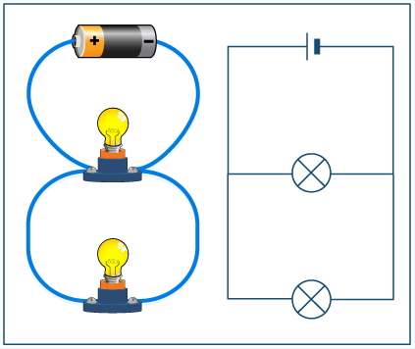

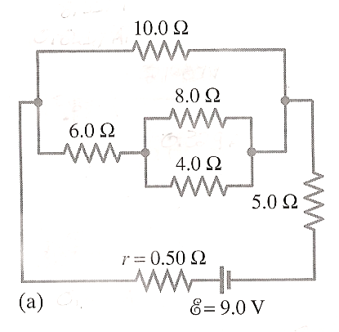

D. Due to the multiple branches, current is not the same at all points along the circuit.

- Advantages:

  - each device will draw the same voltage

  - devices that break or are replaced in the circuit will not affect other devices

F.

III. Three Circuit Laws

A. Ohm’s Law

B. Kirchhoff’s current law – the total current flowing into any junction in a circuit equals the total current flowing out of the junction.

C. Kirchhoff’s voltage law – total of all voltage gains and drops around a circuit must equal 0.

IV. Problems

A. What is the voltage of a 0.25 amp current that has a resistance of 12.0 ohms?

B. Determine the resistance in a 3.0 A circuit that is driven by 15.0 volts.

V. Electric Power, AC, and DC Electricity

A. Electric power is the product of the voltage and current in a circuit.

B. Watts (W) are the unit of power. One watt is small, so generally a kilowatt or megawatt is used.

C. Horsepower is not used as much anymore. 1 hp = 746 W.

D. The power is the same in a 200 V/5 amp circuit or a 1000 V/1 amp circuit. Amperages are generally very low, so voltage and power are usually large.

E. Direct current (DC) flows in one direction only. Batteries operate this way.

F. Alternating current (AC) is current that flows in both directions. It is easy to generate and transmit over large distances, so it is used for high-power applications.

