I. Temperature Scales

A. What does temperature measure?

Temperature measures the average energy of all the molecules in a particular substance. As the energy in the particles increases, so does the temperature.

B. Fahrenheit

Used in the United States for common measure, water freezes at 32°, boils at 212°, and the body’s temperature is 98.6°.

C. Celsius

The metric system for temperature, also used internationally. Water freezes at 0°, boils at 100°, and body temperature is around 37°.

D. How does a thermometer work?

Since most materials expand as temperature increases, a tube is filled with a liquid that will expand (upward) as temperature increases. Traditionally mercury (gray) is used, but most thermometers are now red-dyed alcohol.

- How does a thermostat work?

A metal strip bends down as the temperature increases, eventually forcing a switch to turn off. As the temperature lowers and the metal cools, the switch is turned on as the metal curls back up.

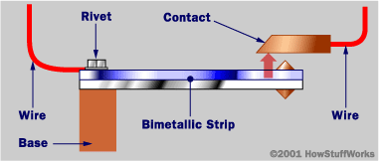

II. Thermal Energy

A. Heat – is a measure of the total kinetic energy (energy of motion) of all the particles in a system.

“Cold” objects can have a lot of heat because of the large number of molecules (glacier or iceberg)

“Warm” objects may not have a lot of heat because there are few molecules (match)

B. calorie – unit for measuring heat; it is the amount of energy needed to raise the temperature of 1 gram of water by 1 degree Celsius.

1. Food – labels are listed using Calories, the capital “C” makes it different!

2. 1 Calorie = 1 kilocalorie = 1000 calories

C. Specific Heat – the amount of energy needed to change the temperature of a certain material

1. Differences between materials – low specific heat materials (metals) very easily can and lose heat

2. Water – is one of the highest specific heat materials naturally occurring on earth – it takes a lot of energy to heat it up/a lot of energy to cool it down

III. Heat Flow – always flows from “hot” to “cold”

A. 1st Law of Thermodynamics – the amount of heat (energy) in a system (or universe) is fixed, it can move between objects, but can never be created or destroyed.

B. Thermal equilibrium – is established when heat stops flowing between objects; both materials are at the same temperature (ice cubes finish melting in soup)

IV. Heat Transfer

A. Conduction – transfer of heat by direct contact of molecules

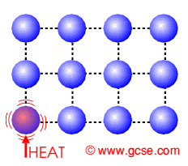

1. Particle Collisions – collisions of molecules makes particle move faster (makes it warmer)

2. Conductors vs. Insulators – particles that are densely packed (like solids) transmit heat the best (more collisions); insulators decrease the number of particle collisions that take place.

B. Convection – only occurs in liquids/gases because warmer fluids are less dense and will float above denser, colder air.

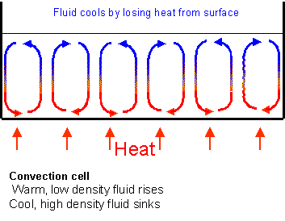

1. Weather – warm air rising at the equator and cool air sinking at the poles creates the air movement that is necessary for weather.

2. Density of air – warm air less dense because the particles are moving faster and are farther spread apart.

3. Forced convection – a method of heating a house by pumping hot water/steam through a radiator to warm up air.

C. Radiation – waves of energy, such as light, that is absorbed by objects

1. Solar – ultraviolet energy is absorbed by objects on the earth’s surface to warm them up

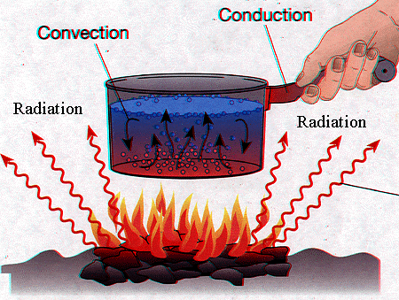

2. Colors of stars – because red has the longest wavelength, red stars are coolest, and blue stars (short wavelength) are warmest

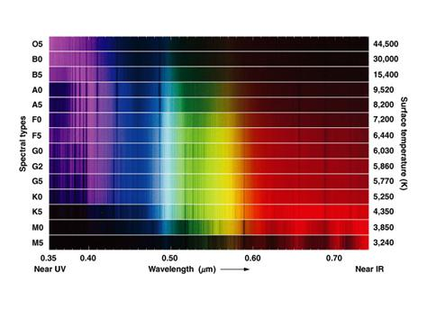

3. Absorption vs. emission

a. metallic objects – reflect most of the energy that hits them; good conductors are usually good reflectors

b. absorbers/emitters – objects that absorb heat well (blacktop), tend to also be good emitters of heat

