I. Chemical Equations – are a “recipe” that shows the compounds, number of molecules, and states of matter needed for a reaction.

1. reactant – the compound(s) that start the reaction; left of completion arrow.

2. product – the compounds that are made from the reactants; right of the completion arrow.

3. Chemical equation:

II. Electric charges

1. positive charges – the protons in the nucleus provide a positive charge.

2. negative charge – the electrons in the cloud around the nucleus provide a negative charge.

3. neutral – in atoms that have not reacted with each other, the number of protons and electrons are equal.

III. Ions

1 definition – any particle that has unequal numbers of protons and electrons.

a. valence electrons – are the number of electrons an element can potentially use in a reaction.

Group 1 – 1 Group 2-12 – 2
Group 13 – 3 Group 14 – 4
Group 15 – 5 Group 16 – 6
Group 17 – 7 Group 18 – 8

b. positive ions – are formed when particles lose electrons; cations

c. negative ions – are formed when particles gain electrons; anions

IV. Shared electrons

1. electron dot diagram – graphically shows the number of valence electrons on an atom

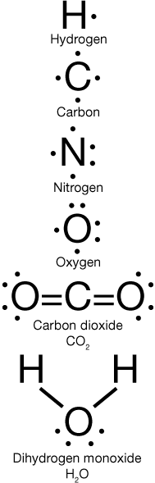

V. Chemical bonds

1. definition – when atoms give, take, or share electrons to achieve eight total valence electrons/holds atoms together

2. bond types:

a. ionic – when metals give away electrons to
nonmetals that prefer to take electrons.

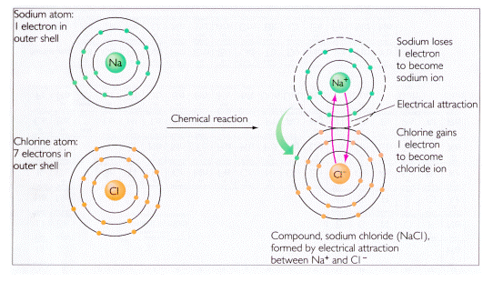
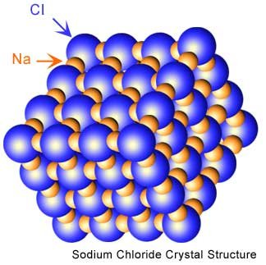

b. covalent – when nonmetals share electrons with
each other.

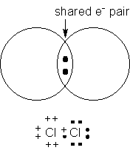

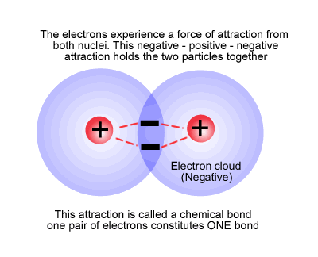

VI. Acids and Bases

1. pH scale – is a 0-14 scale that measures how acidic or basic a substance is.

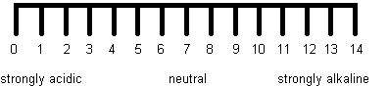

2. Hydrogen ions (H⁺) – are formed when acids are dissolved in water; more H⁺ - closer pH is to zero.

3. Hydroxyl ions (OH⁻) – are formed when bases are dissolved in water; more OH⁻ - closer pH is to fourteen.

4. strong acids – compounds that dissolve well in water/conduct electricity well/break up 100% into H⁺ ions

5. weak acids – compounds that dissolve poorly in water/conduct electricity poorly/very few break up into H⁺ ions

6. strong bases – compounds that dissolve well in water/conduct electricity well/break up 100% into OH⁻ ions

7. weak bases – compounds that dissolve poorly in water/conduct electricity poorly/very few break up into OH⁻ ions

VIII. Neutralization

1. definition – a reaction that results in the pH of the final solution being seven (neutral).

2. examples – whenever an acid reacts with a base:

NaOH _{(aq)} + H₃PO₄ _{(aq)} → HOH _{(ℓ)} + Na₃PO₄ _{(aq)}

Water salt

