The Particle Model of Matter

I. Atoms

A. Definition – small particles which compose all forms of matter; they cannot be broken down any further and still maintain the properties of that element.

B. History –

Democritus – atomos = "indivisible"; Plato and Aristotle did not agree and their opinion that matter was continuous prevailed

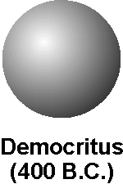
Dalton – matter consists of tiny particles called atoms;
atoms cannot be created, destroyed, subdivided or
converted from one type to another by chemcal means
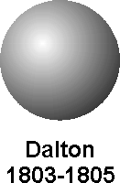
Thomson – Atoms made up of smaller particles; one of them is the negatively charged electron.
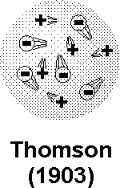
Rutherford – Atoms mainly empty space with the
majority of the mass concentrated in a small,
positively charged region or nucleus
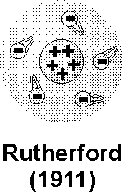
Bohr – Electrons in an atom are allowed to travel only
in certain circular orbits of varying radii.
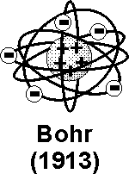

Schrödinger – electron location can only be spoken of
in terms of a probability of being at a particular location.
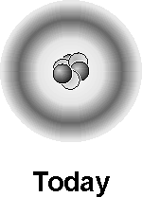

II. Elements

A. Definition – substances that cannot be broken down any further and still have the properties of that substance.

B. Symbols – either the first letter (or two) of the element or it is derived from the ancient Greek/Roman name

C. States of elements

1. gas – few on periodic table (about eleven); mostly on the right side; nonmetals.

2. liquid – mercury and bromine

3. solid – all other elements; all metals except mercury.

D. Molecules

1. Monatomic – made of only one atom.

2. Diatomic – made of two atoms

e.g. NaCl or table salt
7 elements always occuring as diatomic – H₂, O₂,
N₂, F₂, Cl₂, Br₂, I₂

3. Polyatomic – made of three or more elements (ozone O₃ and water H₂O are examples).

E. Chemical formulas

Show the number of atoms of each element in a molecule.

III. Compounds

A. Definition – a substance made of two or more atoms bonded together.

B. Examples – CO₂ (carbon dioxide) C₆H₁₂O₆ (sucrose)

C. Law of definite proportions – all molecules must be made of whole numbers of atoms; all molecules of the same kind are identical in structure.

D. Mixture – two or more substances combined; but that can be separated from one another.

E. Alloy – a mixture of metals

F. Law of conservation of mass – the amount of materials used to start a reaction must equal the amount of matter that completes a reaction.

G. Law of multiple proportions – atoms can be combined in different ratios to form different compounds.

1. reactant – the compound(s) that start the reaction; left of completion arrow.

2. product – the compounds that are made from the reactants; right of the completion arrow.

3. Chemical equation:

IV. Electric charges

1. positive charges – the protons in the nucleus provide a positive charge.

2. negative charge – the electrons in the cloud around the nucleus provide a negative charge.

3. neutral – in atoms that have not reacted with each other, the number of protons and electrons are equal.

V. Ions

1 definition – any particle that has unequal numbers of protons and electrons.

a. valence electrons – are the number of electrons an element can potentially use in a reaction. They are equal to the number of electrons on the highest energy level.

Group 1 – 1 Group 2-12 – 2
Group 13 – 3 Group 14 – 4
Group 15 – 5 Group 16 – 6
Group 17 – 7 Group 18 – 8

b. positive ions – are formed when particles lose electrons; cations

c. negative ions – are formed when particles gain electrons; anions

