Name: Date:

Take Home Problems – Please answer on a separate sheet of paper. These are worth 25% of your final grade.

1. Describe the proportionality in the graph below:

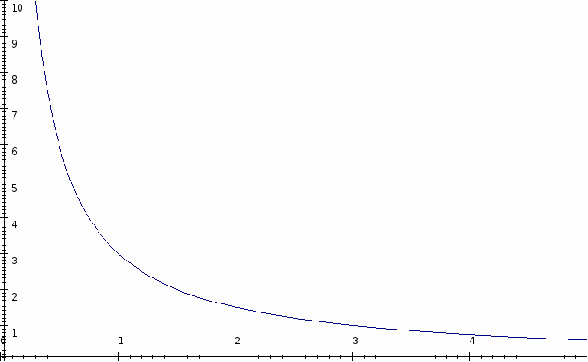

2. If the shape of a graph is linear, then the two variables being compared are

related to each other.

3. What is the density of an object that has a mass of 58.15 g and a volume of 18.3 mL?

4. Find the mass of an object whose density is 3.61 g/mL and has a volume of 25 mL.

5. A graduated cylinder is filled with 25.0 mL of water. A rock is placed inside and its volume is raised to 35.3 mL. What is the volume of the rock?

6. A runner jogs 3.8 miles in 0.40 hours. What is the runner’s speed?

7. A train moves at a speed of 85.0 m/s. How long will it take to travel 25000 m?

8. Which object will be more difficult to stop at a red light when traveling the same speed: a full dump truck or a man on a bicycle? Explain.

9. What are two things that can cause a force? Explain using an example.

10. What is the relationship between gravity and weight? Explain.

11. What is the mass of an object that has a weight of 750 N?

12. What will be the force needed to accelerate a 5.0 kg block at 2.3 m/s2?

13. If a 1500 N force is applied to a 125 kg cart, what will be its acceleration?

14. What affects the time it takes for an object to freely fall to the ground?

15. If an object takes 2.0 s to fall to the ground, how high above the ground was it?

Use the diagram below to answer questions 16-17:

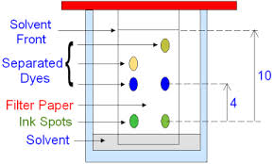

16. Calculate the retention factor (Rf) for the darkest spot.

17. Which spot dissolves best in the solvent? Explain.

18. What is the significance of a positive or negative value when indicating direction?

19. What is the momentum of a 45.0 kg bicycle moving at 6.0 m/s in a backwards direction?

20. Which pendulum swings faster – one with a bob that swings at the end of a 25.0 cm string or one with a bob that swings at the end of a 50.0 cm string? Explain.