I. Properties of Solids

A. Density – is the relationship between mass and volume; density = mass divided by volume

- float vs. sink – objects that are more dense will sink in objects that are less dense.

- units – grams per cm³ or grams per mL (mass units divided by volume units)

3. describes how tightly packed the molecules are in a substance.

Generally: solids > liquids >>> gases

B. Hardness – is a measure of an object’s resistance to scratching. For minerals, Moh’s scale is used.

C. Elasticity – is a measure of an object’s ability to return to its original shape.

D. Metals:

- malleability – a measure of a metal’s ability to be bent or reshaped.

- ductility – the ability for a metal to be drawn into a wire

- tensile strength – the measure of how much pull a wire can withstand before it snaps.

- magnetism – the ability for the particles in a metal to create a magnetic field that can attract/repel other metals. (Iron – “ferrous metals”)
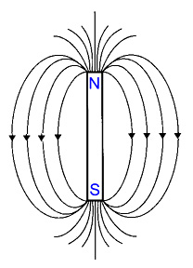
II. Fluids – anything that has no definite shape

A. Density

1. Effect of Temperature on Liquids – as temperature increases, density decreases because molecules get farther apart (exception – water at low temperatures)

2. Gases – density is dependent on temperature and pressure of the gas.

B. Buoyancy – measure of the upward pressure a fluid exerts on an object.

1. Archimedes’s Principle – the force exerted on an object in a liquid is equal to the weight of the fluid it displaces.

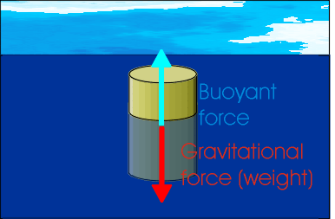

2. sink vs. float – an object will sink if its buoyant force is less than the object’s weight.

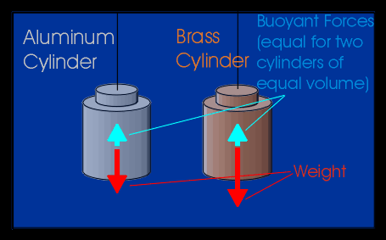

C. Gases

1. Effect of Temperature – As the temperature of a gas increases; so does its volume (Charles’s Law).

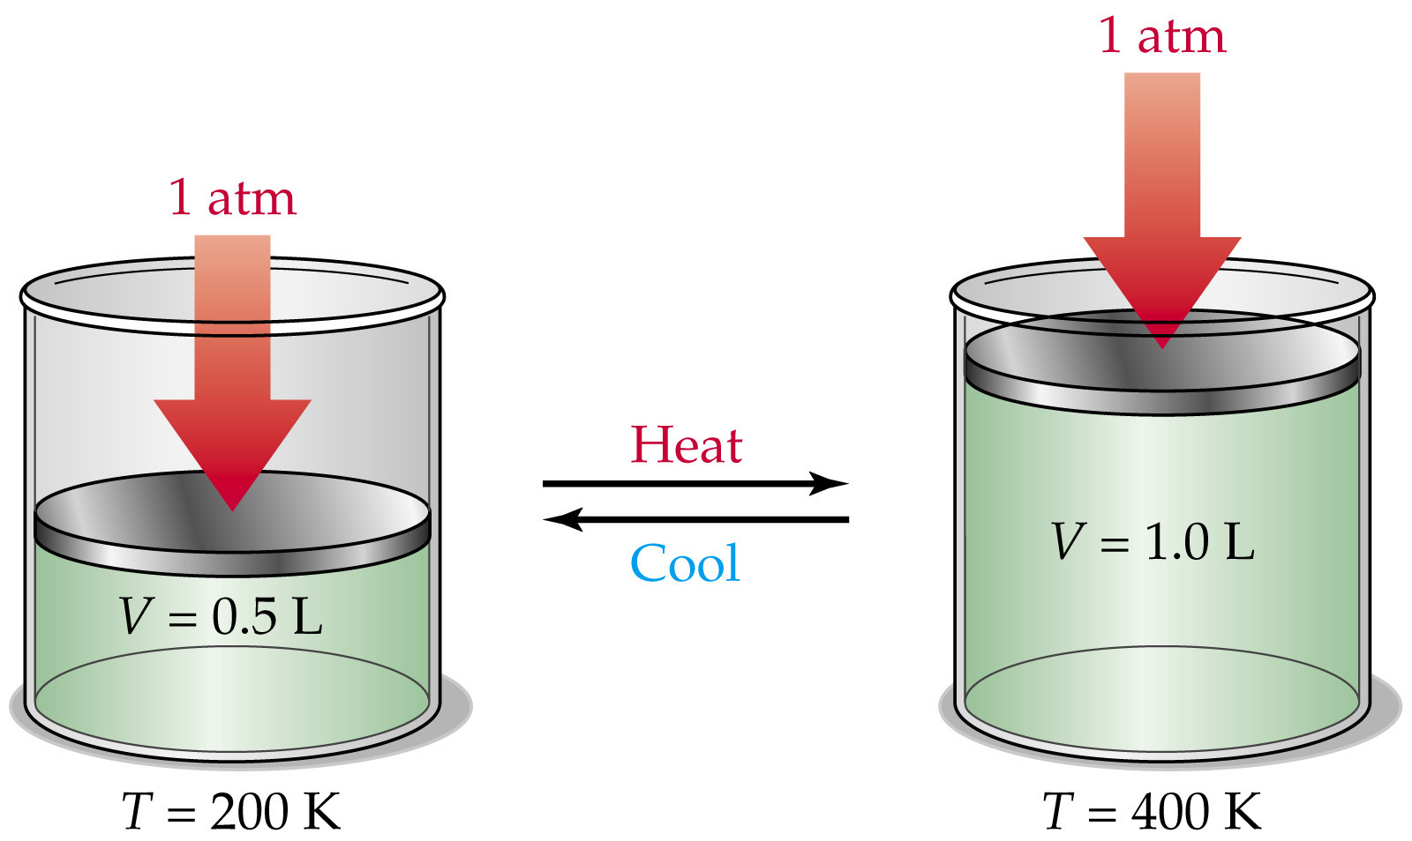

2. What is Pressure? – is a measure of the number of particles colliding with the surface of a material.

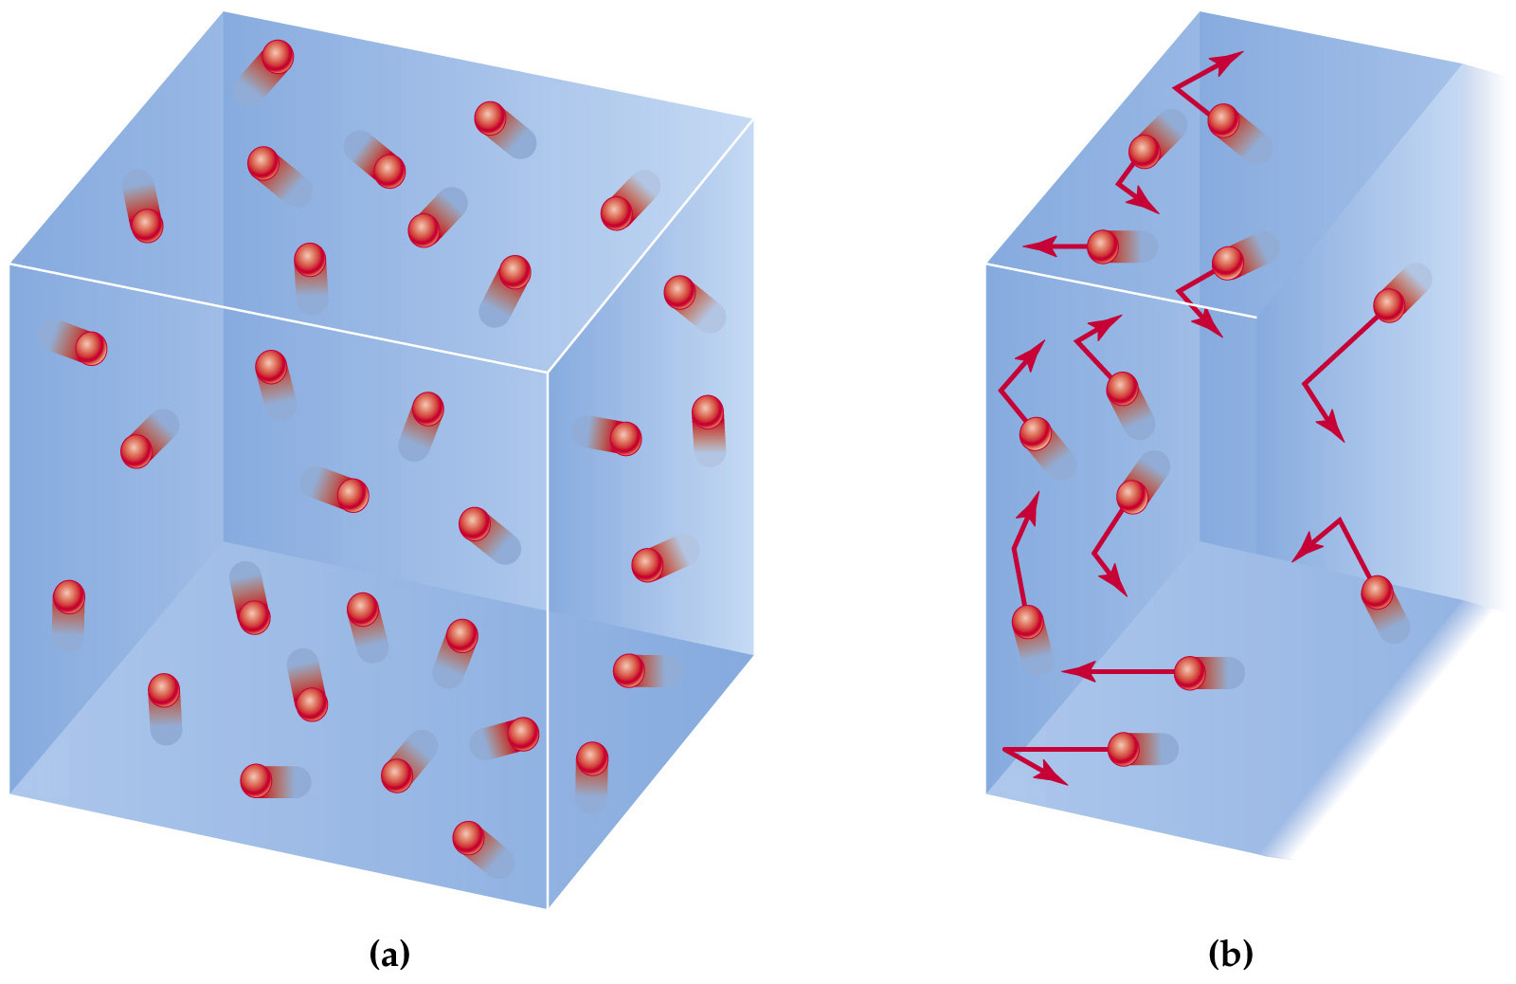

3. Effect of Pressure – As pressure increases, the volume of a gas decreases (Boyle’s Law).

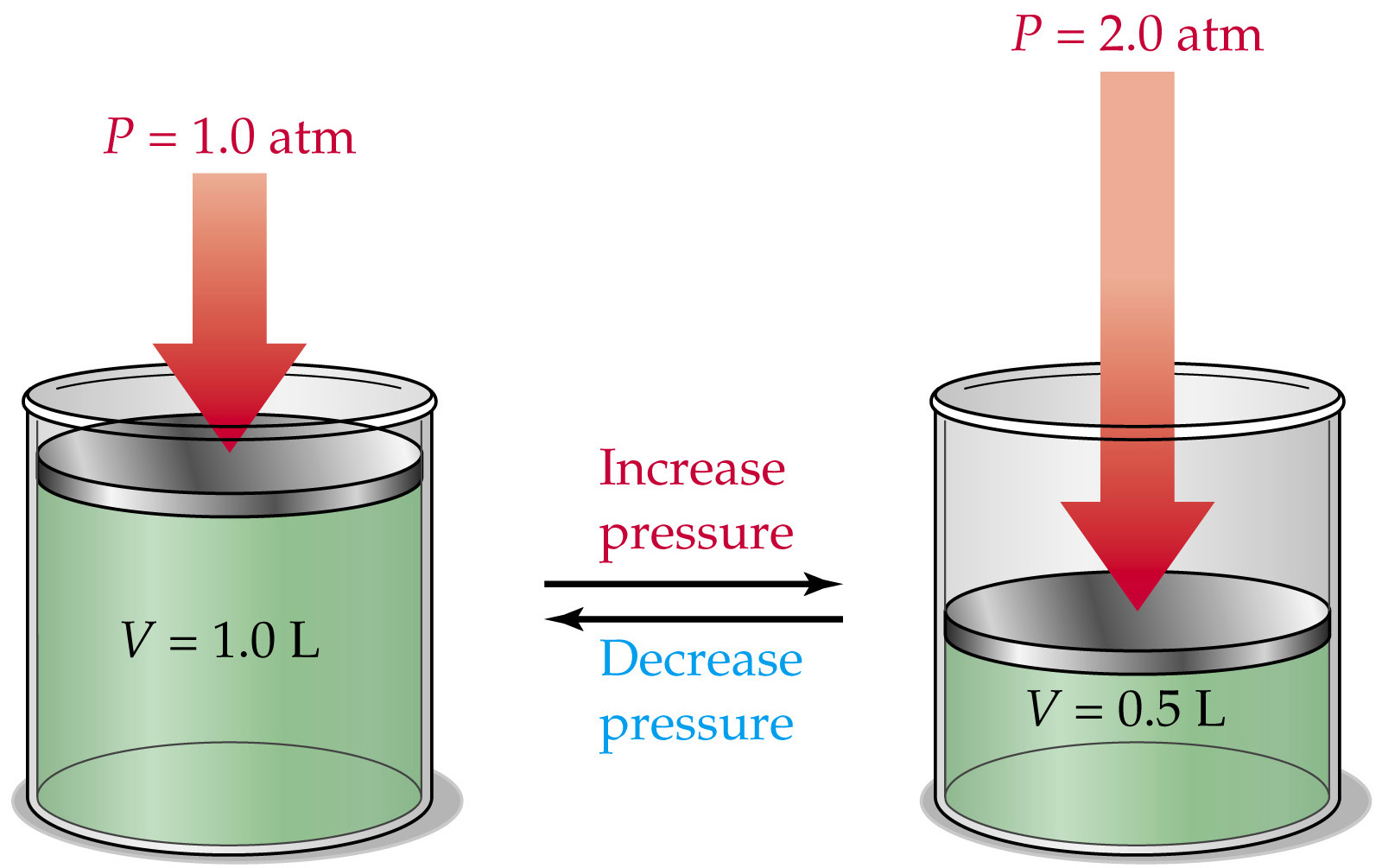

D. Viscosity of Fluids

1. What is it? Is a measure of a substance’s resistance to flow.

2. What determines a fluid’s viscosity? The larger the molecules in a fluid, the more the molecules collide with each other and prevent them from moving (flow).

3. Relationship to temperature

a. liquids – as temperature increases, viscosity decreases because the liquid molecules can move faster.

b. gases – as temperature increases, viscosity increases because the molecules collide with each other more; preventing movement (flow).

