I. Properties of Water

A. Shape – water has a “teddy bear” shape, with hydrogen atoms located on one side of the molecule
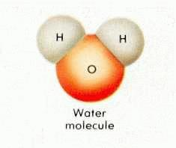

B. Polarity – when the electrons are not distributed evenly within a molecule, the molecule exhibits negative and positive poles, like a magnet

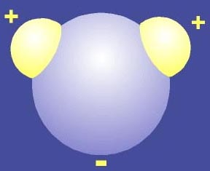

C. Solutions – water is called the “universal solvent” because it dissolves a variety of compounds.

D. Hydrogen bonding

1. Ice/water – water molecules are attracted to each other because of its polarity, however, they spread out when frozen to keep like poles apart

2. Trees – water molecules attract each other to move up a tree, against the force of gravity.

II. Solubility

A. Components of a solution

1. solute – the material that is dissolved

2. solvent – the material that dissolves the solute

B. “Like dissolves like” – molecules that are polar dissolve in other polar materials; molecules that are nonpolar dissolve in other nonpolar substances

III. The Water Cycle – surface water evaporates and collects into clouds, condenses in the cooler air, falls as precipitation and soaks into the earth where it will eventually run back into the streams/lakes.

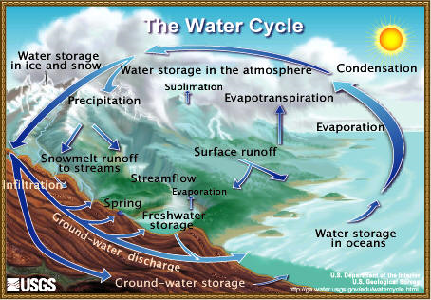

IV. Water Tests

A. Turbidity – measures the cloudiness of water by lowering an object into water until it can no longer be seen

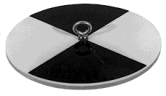

B. Nitrates – excess nitrates (found in fertilizers/near farmland) cause large amounts of algae to grow

C. Phosphates – excess phosphate can also cause an increase in the amount of algae in water

D. Biological Oxygen Demand – a water sample’s oxygen level is measured before and after bacteria decomposes organic material.

V. Acids

A. Formulas – begin with “H”: ex. HCl, H₂SO₄, HF, HNO₃ – does not have to be just one hydrogen atom

B. Properties

1. taste – sour

2. reaction to body – irritation to skin/burns to eyes

C. Compounds they react with: metals, bases, compounds that contain carbonate (CO₃) or sulfite (SO₃)

D. Examples

1. Body: stomach (for digestion of food)

2. Foods – many fruits (lemon, apple), carbonated beverages

VI. Bases

A. Formulas – end with “OH”; ex. KOH, NaOH, NH₄OH, and Ca(OH)₂ – does not have to be one hydroxyl group

B. Properties

1. taste – bitter

2. reaction to skin – corrosive to skin/ “melts” /feels slippery

C. Compounds they react with – acids, some metals, organic material (contains hydrogen and carbon)

D. Examples

1. Products – cleaning materials (ammonia, drain cleaner) and antacids (Maalox, Tums)

2. Others – seawater; eggs (slightly)

VII. pH Scale – A 0 to 14 scale for measuring how acidic or basic a compound is

A. Scale:

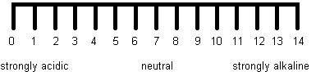

B. Comparison of pH Values

Each smaller number is ten times more concentrated than the number after it

C. Indicators – Substances that change color based on the pH of a substance

