Name: Date:

Molecular Modeling

You should search for images of the structural formulas of the compounds listed in the table. Use the image and this handout to fill out the table.

Data:
Compound Name | Formula | # bonds | # dbl | # triple
3-hexyne
Pyruvic acid
Arbutin
Ibuprofen
Linalool
Propyl acetate
* – yes or no answer

Turn over

Compound | Alcohol* | Ether* | Ester* | Aldehyde* | Ketone* | Carboxylic acid* | Amine*
* – yes or no answer

Remember that R represents any chain of carbons

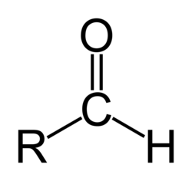 | aldehyde
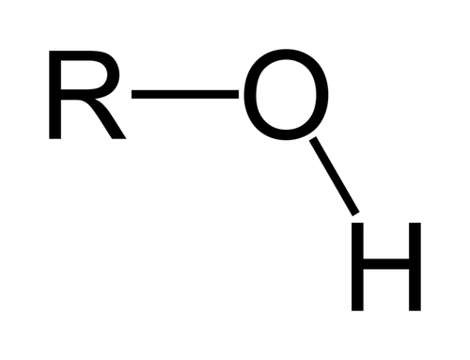 | alcohol
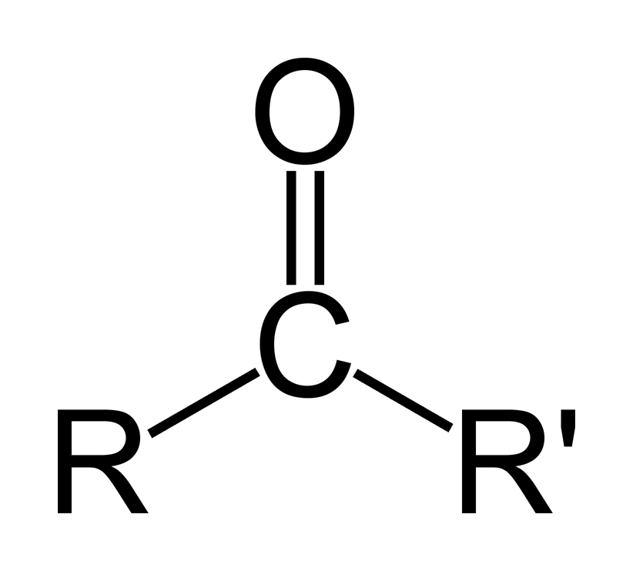 | ketone
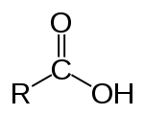 | carboxylic acid
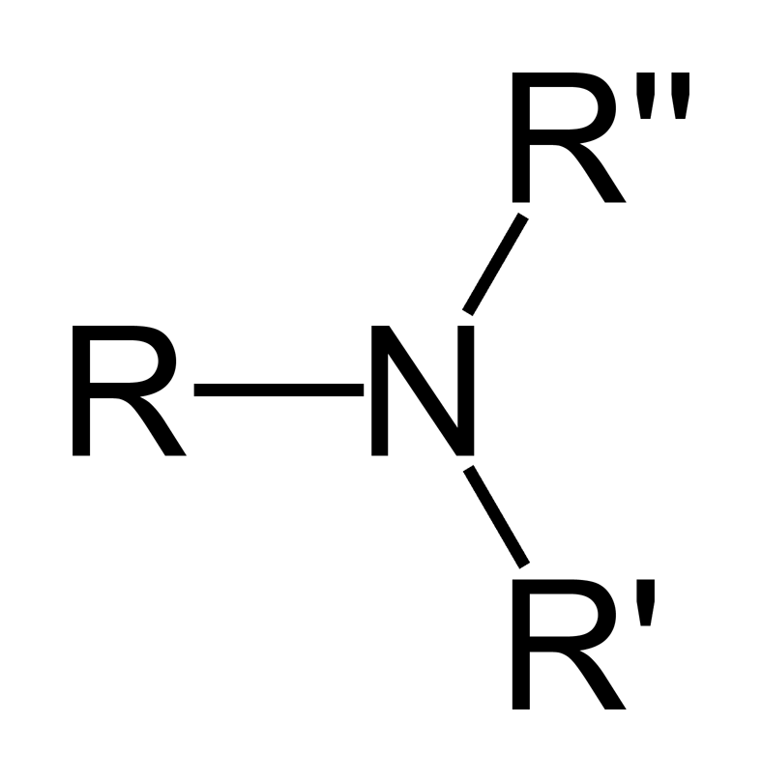 | amine
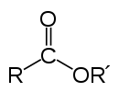 | ester
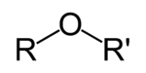 | ether

