Name: Date:

Molecular Modeling

Ball Color Element Ball Color Element Ball Color Element
Black Carbon Gray Phosphorus Blue Nitrogen
Yellow Hydrogen Red Oxygen 6-hole yellow or red Sulfur
Green/Orange/Purple F, Cl, Br, I

Data:
Compound Name | Formula | # bonds | # dbl | # triple | Alcohol* | Ether* | Ester*
* – yes or no answer

Compound | Alcohol* | Ether* | Ester* | Aldehyde* | Ketone* | Carboxylic acid* | Amine*
* – yes or no answer

Remember that R represents any chain of carbons

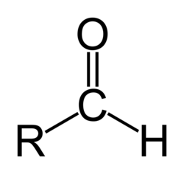 | aldehyde
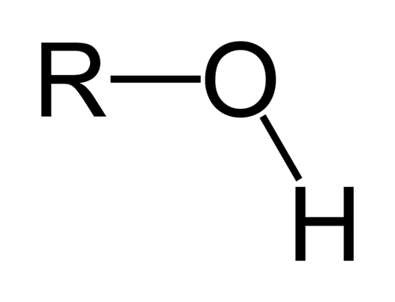 | alcohol
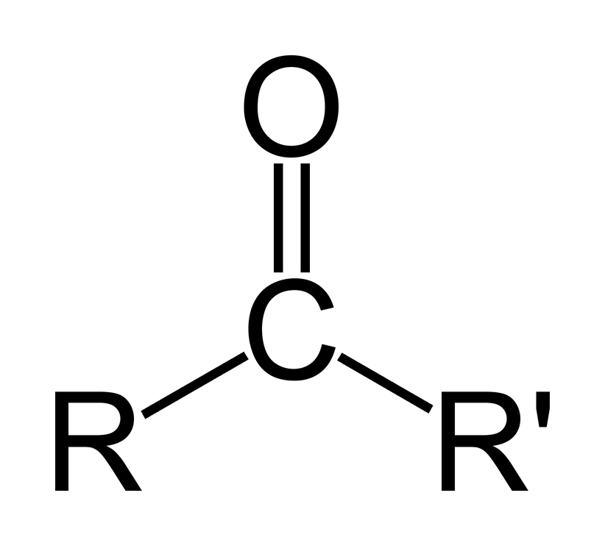 | ketone
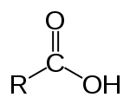 | carboxylic acid
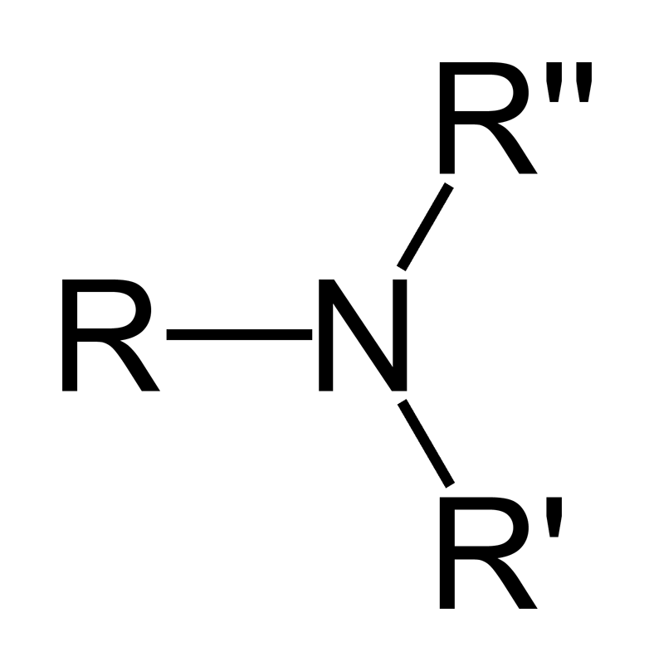 | amine
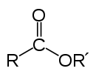 | ester
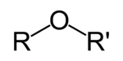 | ether

